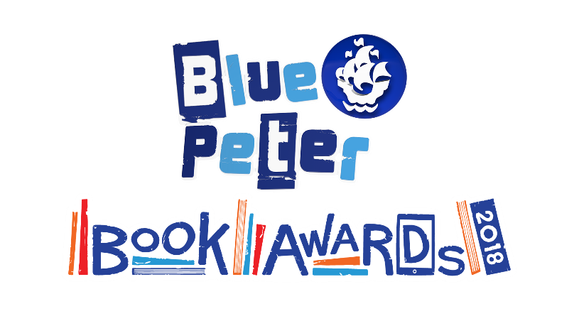
Blue Peter Book Awards 2018: School Judge Application
BookTrust, the national reading charity that manages the Blue Peter Book Awards, is looking to recruit at least 200 Year 5 and 6 pupils, or P6 and P7 in Scotland, from 12 primary/middle schools located across the UK to select the winning books for 2018 in two Award categories: Best Story and Best Book with Facts. Children who participate in the award will receive a Blue Peter badge following the winners’ announcement in March 2018.
To register your interest to be one of the 12 judging schools, please fill in the below form and return it to bluepeter@booktrust.org.uk by Friday 13 October 2017, 5pm GMT.
Application form
By submitting the form below, you and your school are deemed to accept the following terms and conditions. If your school is selected to judge the Blue Peter Book Awards 2018 you agree to:
- Assign one dedicated member of staff to manage the Award process in your school from November 2017 to March 2018
- Recruit a minimum of 20 pupils in year 5 and/or 6 (or P6 and P7 in Scotland) to vote for their favourite book in each category. Any pupil who votes must have read all three shortlisted books in the category they are voting in.
- The scheduling of the Award, as follows:
  - Participating schools will receive copies of the six shortlisted books from 16th November 2017 UNDER EMBARGO
  - Shortlist titles announced publicly on Blue Peter programme airing 23rd November 2017
  - Appointed staff member to circulate copies of the shortlisted books to pupil judges after 23rd November 2017
  - Pupils' votes must be received at BookTrust by Monday 29th January 2018, 5PM GMT.
- Allow Blue Peter to film a selection of participating pupils for their Award's show if requested. Please note, only one or two schools will be required for this
- Supply supporting material from your pupils for use on the BookTrust website, which could include: reviews of the books; illustrations of the book jackets; photographs of the pupils with the books; and short films of the pupils discussing the books and the Awards
- Promote your school's participation to local and regional media
- Provide feedback to BookTrust in March 2018 after the winner’s announcement (schedule 1 March 2018) and a 4-month review in July 2018 on your school's experience of the judging process and its impact on the children involved. The feedback forms will be accompanied with the Blue Peter badge forms for the children that participated to complete.

To find out more about the Blue Peter Book Awards, visit: www.booktrust.org.uk/bluepeter If you have any questions, please email: bluepeter@booktrust.org.uk or call Charlotte Copping, Prizes and Awards, on 020 7801 8845.

All fields required to be filled in
CONTACT DETAILS
Primary/middle school name | School full postal address | Postcode | Region
Name of member of staff managing the Awards process | Job title | Work telephone number | Email address

SCHOOL DETAILS
Type of school | Gender (F/M/MIXED) | Total Number of pupils | Percentage of all pupils receiving free school meals | Number of Year 5s participating* | Number of Year 6s participating* | Total pupils participating

What do you think your school and pupils will get out of the experience of judging the Blue Peter Book Awards 2018?
[Please expand box as necessary]

BookTrust will collect your personal information, such as teacher/librarian names and name of the school you work at, email address, and telephone numbers, to enable your participation in The Blue Peter Book Awards 2018.
BookTrust is the data controller of the data submitted via this Entry form. Personal data collected shall only be kept for as long as necessary for the Awards. Please feel free to ask questions about what happens to the personal data collected via this Entry form or let us know if you would like to correct or update the personal data submitted by contacting us via BookTrust at bluepeter@booktrust.org.uk

* Please note: you do not have to provide both year 5 and year 6 pupils (P6 and P7), just a minimum of 20 pupils in total to vote in each category. You can involve more than 20 pupils, but you must ensure that each pupil who votes has read all three of the books within their chosen category.

