New BookTrust Writer in Residence bridges gap between video games and reading

Taran Matharu announced as the new BookTrust Writer in Residence

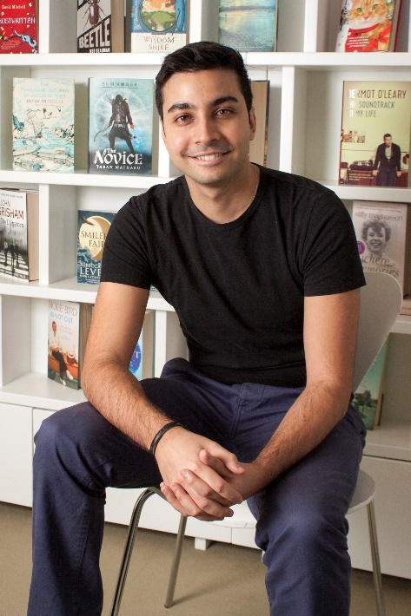

Taran Matharu, the New York Times bestselling children's writer and Wattpad sensation, well known for the Summoner series, has been appointed the new online Writer in Residence for the UK’s largest children’s reading charity, BookTrust.

Taran, who takes over from Sarah McIntyre, starts his six-month residency with a vlog introducing his exciting plans for the forthcoming months which will explore the benefits of reading and writing online, being a young writer and the intersections between books and gaming.

Taran Matharu says about his residency at BookTrust:

“I am so incredibly grateful to BookTrust for giving me the opportunity to pursue a cause that is very close to my heart - bringing the joy of reading to kids and teens across the country. It’s also my hope that I will be able to inspire young writers, both by my own example and highlighting the successes of other young authors. I can't wait to share my thoughts with you all!”

Highlights of Taran’s residency will include his inspiration for the Summoner series and a series of features looking at the relationship between video games and reading, two hobbies Taran believes need not be mutually exclusive.

Diana Gerald, BookTrust CEO said:

“We are delighted to welcome Taran as the next BookTrust Writer in Residence. The project gives visitors to the BookTrust website a unique insight into the minds of acclaimed writers. We fully support Taran’s mission to bridge the gap between video games and reading because to help get children turning pages, they need to be offered books that excite them. Taran’s thrilling books certainly fit that bill, especially for some of the more reluctant readers.”

The BookTrust Writer in Residence project has been running since March 2009 and has featured several authors and illustrators including Cressida Cowell, Sita Brahmachari, Patrick Ness, Polly Dunbar, Bali Rai, Matt Haig, Laura Dockrill, Chris Riddell, Sarah McIntyre, Philip Ardagh and Phil Earle. The residency encourages each writer or illustrator to explore topics that they are passionate about, with past residents exploring themes such as the power of stories, diversity in children’s literature and the importance of libraries.

Keep up-to-date with all Taran’s vlogs and blogs here

ENDS

Press Contacts: Bethan Phillips, Press Officer, BookTrust, Bethan.phillips@booktrust.org.uk, 020 7801 8848

Notes to Editors

BookTrust is the UK’s largest children’s reading charity. We work to inspire a love of reading in children because we know that reading can transform lives. Each year we reach 3.4 million children across the UK with books, resources and support to help develop a love of reading. Every parent receives a BookTrust book in their baby’s first year. Our books are delivered via health, library, schools and early year’s practitioners, and are supported with guidance, advice and resources to encourage the reading habit. Reading for pleasure has a dramatic impact on educational outcomes, well-being and social mobility, and is also a huge pleasure in itself. We are committed to starting children on their reading journey and supporting them throughout. booktrust.org.uk

Taran Matharu was born in London in 1990 and found a passion for reading at a very early age. His love for stories developed into a desire to create his own, writing his first book at nine years old. Straight after graduating with a first class degree in Business Administration, Taran was keen to explore a new avenue and get inside the publishing world, landing an internship in Digital Sales at Penguin Random House, from June to September 2013. At twenty-two, while taking time off to travel, Taran began to write the New York Times bestselling Summoner series as part of NaNoWriMo 2013. After posting the story on Wattpad.com, it received over three million reads in less than six months. After this was featured by NBC News, Taran decided to launch his professional writing career and has never looked back.

