Kid Normal authors sign up for Blue Peter Book Awards
Greg James and Chris Smith join judges line up
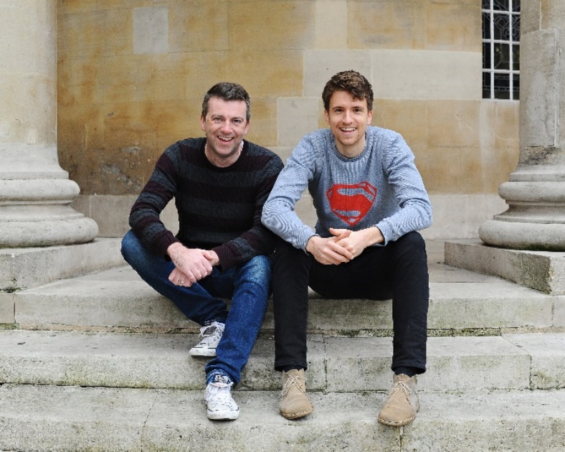
11 September 2017 - Drivetime DJs Greg James and Chris Smith join an impressive judging panel for this year’s Blue Peter Book Awards.
The authors of the hugely successful Kid Normal will sit on an expert panel alongside English performance poet and author-illustrator Laura Dockrilll, School Librarian of the Year 2016 Amy McKay and Blue Peter editor and non-voting chair Ewan Vinnicombe.
Managed by BookTrust, the UK’s largest children’s reading charity, the immensely popular Blue Peter Book Awards honour amazing authors, imaginative illustrators and the best books for children, published in the last 12 months.
The shortlist is made up of six titles and split into two categories: Best Story and Best Book with Facts. The winning titles, voted for by over 200 children from 12 schools across the UK, will be revealed live on Blue Peter on World Book Day on Thursday 1st March 2018, with the winning authors and illustrators appearing on the special awards episode of the show.
Entries are now open for schools to apply to be part of the expert reading panel. Schools need a minimum of 20 pupils in year 5 and/or 6 (or P6 and P7 in Scotland) to vote for their favourite book in each category.
DJ’s Greg and Chris said about the awards “We are thrilled to have entered this brilliant world of children's literature and with our Blue Peter badges firmly in place, a steaming cup of tea to hand, we are ready to settle in for a few days of reading. We can't wait to see what amazing stories these authors have cooked up.”
Blue Peter editor, Ewan Vinnicombe said: “It’s going to be so exciting to see which books will be shortlisted by our fabulous judges for our Book Awards this year. It’s one of the highlights on my Blue Peter year to chair the judges meeting especially because I get to read all the amazing books that enter each year too, picking up some interesting facts and immerse myself in some brilliant characters from the world of children’s fiction. The Blue Peter Book Awards are a key part of our 60th birthday year.”
The judges for this year’s awards are:

- Greg James – Author, TV and Radio presenter
- Chris Smith – Author, Radio Presenter, journalist and broadcaster
- Laura Dockrill - English performance poet and author-illustrator
- Amy McKay - Librarian of the Year Award 2016
- Ewan Vinnicombe - (non-voting chair) Editor, Blue Peter

The Blue Peter Book Awards have been celebrating children’s literature since 2000. BookTrust has managed the Blue Peter Book Awards since 2008. The 2017 winners were Kieran Larwood and David Wyatt who won Best Story with Podkin One Ear and David Long and Kerry Hyndman who won Best Book with Facts for Survivors.
Keep up-to-date with the Awards at www.booktrust.org.uk/bluepeter and on Twitter by following @Booktrust and #BPBA
[Ends]
Press Contacts: Sinéad Gosai, Press Officer, BookTrust, sinead.gosai@booktrust.org.uk, +44 (0)20 7801 8849
Notes to Editors
Additional quotes
Amy McKay “I’m delighted and honoured to be judging the Blue Peter Book Awards. As a school librarian, I know how crucial it is that children are encouraged to develop a love of reading and these awards play an important role in guiding them towards great reads. Bring on the books!”
Laura Dockrill “I am super excited to be judging the Blue Peter book awards. I will be looking for writers that push themselves, think broadly and creatively and use invention and true heart to tell a story.”
About the Judges
Greg James is a familiar voice and face on both radio and TV. He’s the host of Radio 1’s Drivetime show – named Best Entertainment Production at the 2016 ARIA Awards where the judges described it as ‘a joyous listen … ambitious and constantly surprising’. He also presents the UK’s Official Chart every Friday. On-screen, Greg’s recently been busy hosting Children in Need and BT Sport’s new cricket coverage. Earlier in the year he raised over a million pounds for Sport Relief by completing his #GREGATHLON – five triathlons in five different cities on five consecutive days. Greg has no super powers. In his spare time he enjoys the idea of having hobbies. But in reality, he’s made all of them into work.
Chris Smith is a not only a key part of the success of Greg’s show both creatively and in an on-air capacity but an award-winning journalist and broadcaster in his own right. Since 2011 he's been delivering the news to millions of people every day as the presenter of Newsbeat on BBC Radio 1. He'd previously presented on Radio 5 Live and Xfm. Chris enjoyed a previous, glittering, literary career as the winner of the H E Bates Short Story Competition 1981 (under 10s section) with his tale Where Are the Brandy Snaps?. Chris has no super powers either, although he enjoys pretending his cat Mabel can fly by picking her up and running around.
Together on Greg’s show and in their weekly podcast, Chris and Greg are responsible for some of radio's most ludicrous games and characters, which genuinely wouldn't make any sense if we tried to explain them here. Their debut children’s book, Kid Normal, was published on 13th July 2017.
Laura Dockrill is a performance poet and novelist whose wonderfully inventive and vibrant approach to life is reflected in the rich and vividly imagined worlds she creates. Laura grew up in Brixton and attended the Brit School. Laura has always had a vivacious spark, finding creativity in words – from poetry to novels and scripts to song lyrics. She is author of the Carnegie Medal nominated YA novel Lorali, as well as the Darcy Burdock series (Random House) for younger readers, which was also nominated for the Carnegie Medal and shortlisted for the Waterstones Children’s Book Prize in 2014. Other books include Echoes (Harper Collins), a collection of poems and short stories. Laura has appeared on Blue Peter and CBeebies and is a frequent poet performer at festivals including Glastonbury, Hay, Edinburgh, London Literary Festival and Latitude.
Children’s books are at the heart of her work. She curated The Wondercrump World of Roald Dahl exhibition at the Southbank Centre and loves to visit schools and festivals and meet young readers who are as spirited as her. Laura lives in London and is currently working on her new teen novel, a play and a poetry collection. You can follow her on Twitter @LauraDockrill.
Amy McKay has been a school librarian in Corby, Northamptonshire for 12 years. She loves everything about her job; whether she’s organising Zombie Apocalypse training courses or buying lots of lovely new books for students to devour. In 2016 she was named SLA School Librarian of the Year. As well as the day job, for the last 4 years she has been the National Coordinator of the Carnegie and Kate Greenaway Medals.
A self-confessed book addict, she’s rarely found without a book in hand and is passionate about recommending and discussing books with anybody and everybody.
Ewan Vinnicombe (non-voting chair) has been Blue Peter Editor since January 2013.
BookTrust is the UK’s largest children’s reading charity. We work to inspire a love of reading in children because we know that reading can transform lives. Each year we reach 3.4 million children across the UK with books, resources and support to help develop a love of reading. Every parent receives a BookTrust book in their baby’s first year. Our books are delivered via health, library, schools and early year’s practitioners, and are supported with guidance, advice and resources to encourage the reading habit. Reading for pleasure has a dramatic impact on educational outcomes, well-being and social mobility, and is also a huge pleasure in itself. We are committed to starting children on their reading journey and supporting them throughout. booktrust.org.uk

