Sarah McIntyre announced as BookTrust’s New Writer-Illustrator in Residence
Sarah McIntyre, the children's illustrator and writer, well known for her comic Vern and Lettuce and picture books There's a Shark in the Bath and Dinosaur Police has been appointed the new online Writer-Illustrator in Residence for children’s reading charity, BookTrust.
Sarah, who takes over from Cressida Cowell, starts her six-month residency with a vlog introducing her exciting plans for the forthcoming months; which include thrilling drawing competitions and challenges for children.
Talking about why she’s taken on the Writer in Residence platform, Sarah said: “I’m so excited to be BookTrust’s new Writer-Illustrator in Residence, using this awesome platform to highlight how pictures can be amazing ways into stories and can speak to everyone! During my residency, which I’m going to call the Big Red Book Show, I’m hoping to encourage children to draw with others, helping to generate new ideas, discover challenges and create a fun community. I’d like to encourage children (and grownups) to be kind to their drawings, forgive their drawings their foibles, be proud of sharing their work, and continue to make more drawings.”
Highlights of Sarah’s residency will include a ‘Pictures First!’ competition; giving children the opportunity to draw pictures based on a chosen character, which will then be selected to accompany a short story written by a famous writer. Sarah will also be revealing her top tips on drawing and drawing with other people.
In addition to her other publications, Sarah has produced four books with Philip Reeve, including Pugs of the Frozen North which won the Independent Bookshop Week Book Award in 2016 and Oliver and the Seawigs which won the UKLA Book Award in 2015.
BookTrust chief executive Diana Gerald said: ‘The BookTrust online Writer-Illustrator in Residence programme is a wonderful feature, giving visitors to the BookTrust website an invaluable insight into the lives, minds and sketchbooks of acclaimed illustrators and writers. We are looking forward to Sarah’s residency and support her mission to highlight the important role illustrations play when attracting individuals to books and inspiring a lifelong love of reading.”
The BookTrust Writer- Illustrator in Residence project has been running since March 2009 and has featured several authors and illustrators including Cressida Cowell, Sita Brahmachari, Patrick Ness, Nii Ayikwei Parkes, Evie Wyld, Polly Dunbar, Clare Wigfall, Bali Rai, Hannah Berry, Matt Haig, Laura Dockrill, Chris Riddell, Philip Ardagh and Phil Earle. The residency encourages each writer or illustrator to explore topics that they are passionate about, with past residents exploring themes such as the power of stories, diversity in children’s literature and the importance of libraries.
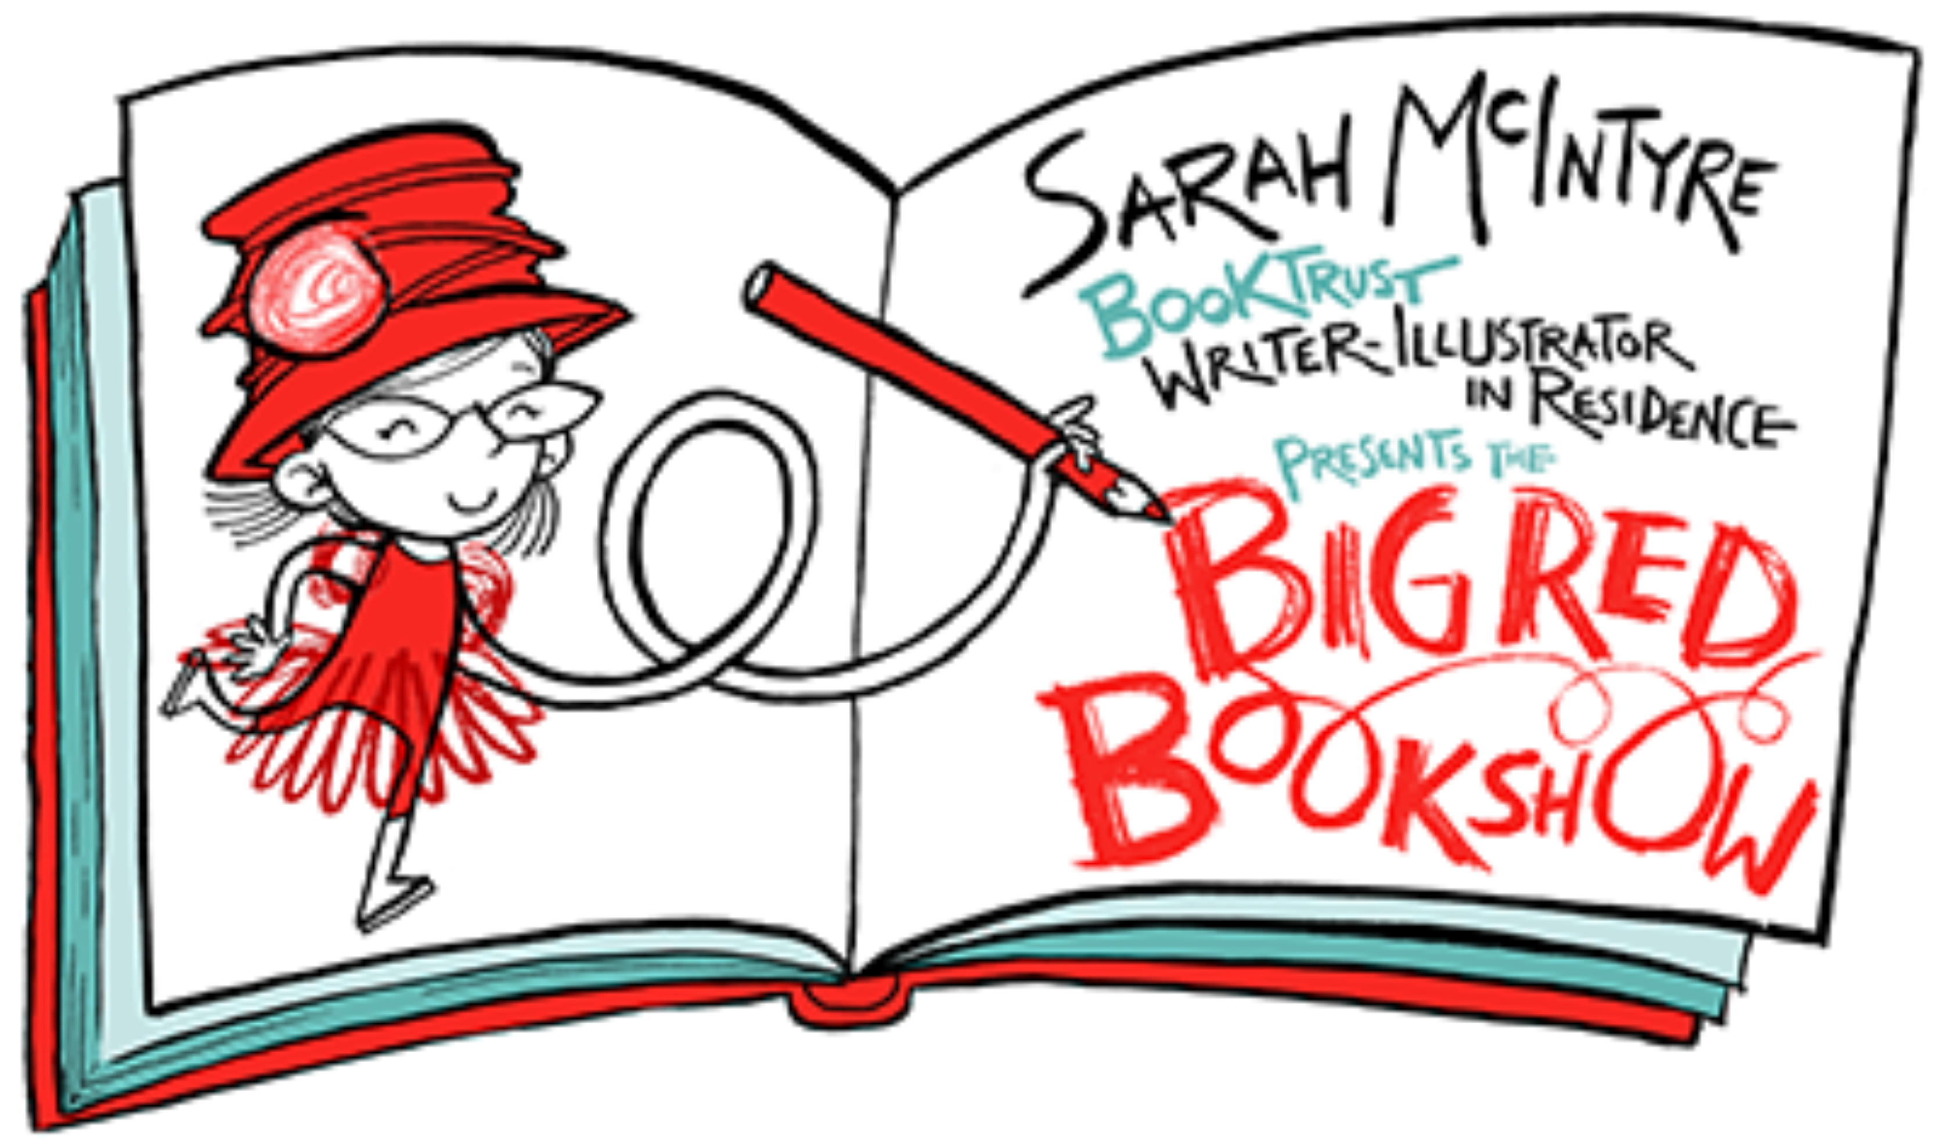
Keep up-to-date with all of Sarah’s vlogs and blogs here: http://www.booktrust.org.uk/books/writing/online-writer-in-residence/

ENDS
Press Contacts: Bethan Phillips, Press Officer, BookTrust, Bethan.phillips@booktrust.org.uk, 020 7801 8848.
Notes to editors
Sarah McIntyre books include the comic Vern and Lettuce, four books with Philip Reeve, including Pugs of the Frozen North and Jinks & O'Hare Funfair Repair, and her picture books include There's a Shark in the Bath, Jampires and Dinosaur Police. She loves creating books and comics with friends, getting inspired by batting around ideas and drawings with them. She's immensely proud of Britain's amazing illustrators and how well their pictures tell stories, and in 2015, set up the #PicturesMeanBusiness campaign calling for people to credit illustrators for their work, in reviews, when sharing artwork on social media and when presenting their books in classrooms.
BookTrust is the UK’s largest children’s reading charity. We work to inspire a love of reading in children because we know that reading can transform lives. Each year we reach 2.5 million children across the UK with books, resources and support to help develop a love of reading, because we know that reading can transform lives. Every parent receives a BookTrust book in the baby’s first year. Our books are delivered via health, library, schools and early year’s practitioners, and are supported with guidance, advice and resources to encourage the reading habit. Reading for pleasure has a dramatic impact on educational outcomes, well-being and social mobility, and is also a huge pleasure in itself. We are committed to starting children on their reading journey and supporting them throughout. www.booktrust.org.uk

