Press Release: Embargoed until 9am, Monday 5 October 2020

*** #PASSTHEPEN: CALL FOR SUBMISSIONS ***

BOOKTRUST REPRESENTS & WATERSTONES CHILDREN’S LAUREATE CRESSIDA COWELL
LAUNCH CAMPAIGN TO PROMOTE EMERGING AUTHORS & ILLUSTRATORS OF COLOUR
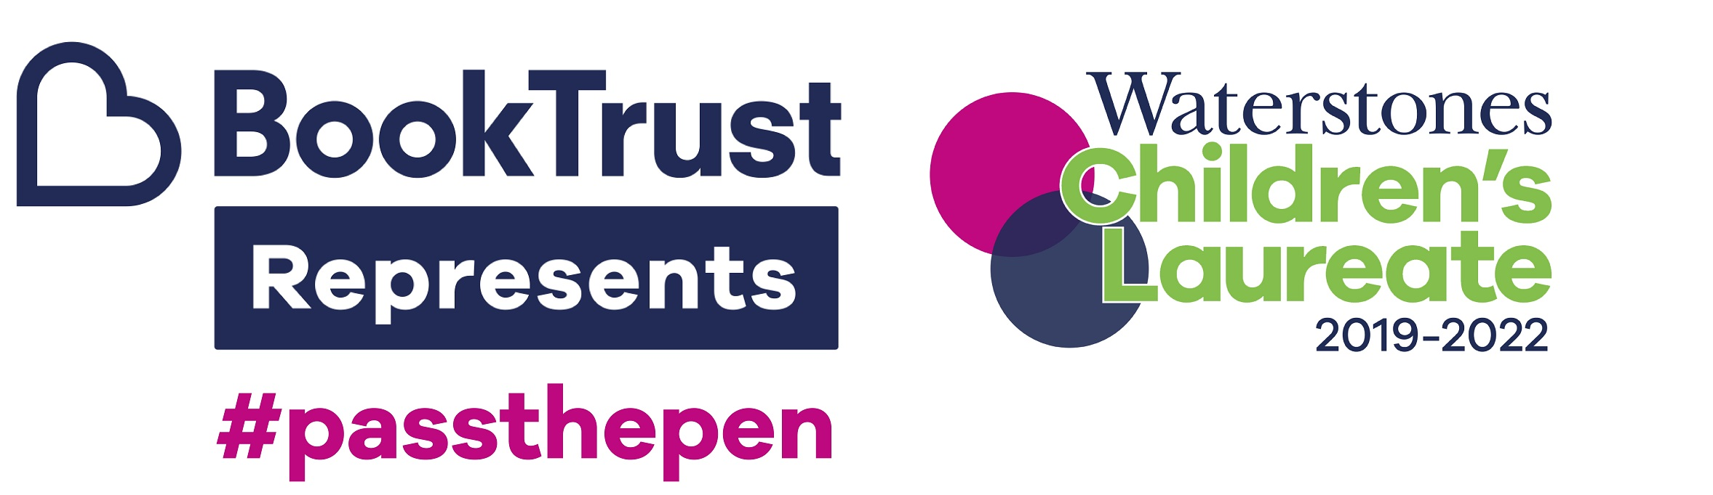
London, 5 October 2020: BookTrust Represents and Waterstones Children’s Laureate, Cressida Cowell, have today opened submissions for #PassThePen, a new campaign designed to help create visibility and generate book sales for emerging authors and illustrators of colour in the children’s books world.

#PassThePen will see fresh talent paired with established, high-profile authors and illustrators, for a takeover of their partners’ Instagram platform for a day to share information about themselves and their work. The week-long campaign will run from 16 – 22 November, featuring a diverse range of genres from picture books to YA.

Some of the authors and illustrators already confirmed to share their Instagram platforms as part of the campaign include Nadiya Hussain, Rob Biddulph, Dapo Adeola, Greg James, Onjali Rauf, Dermot O’Leary, Chris Smith, Holly Bourne, Chris Riddell, Juno Dawson, Laura Dockrill, Benji Davies, Jim Field, Frank Cottrell-Boyce and Holly Smale.

Waterstones Children’s Laureate, Cressida Cowell, will host a different author or illustrator each day throughout the week, and will continue to #PassThePen moving forward by running a monthly social media guest takeover. Point five on Cressida’s Waterstones Children’s Laureate Charter is that ‘every child has the right to see themselves reflected in a book’, integral to which is the visibility of authors and illustrators of colour to readers.

Alongside the #PassThePen ‘takeover’ on Instagram, Cressida and BookTrust Represents will curate a Christmas reading list selected from the titles submitted for the campaign. This will be released on Monday 16 November, alongside a Twitter campaign - supported by Alex Wheatle, Candy Gourlay, Floella Benjamin and Nikesh Shukla - to encourage further recommendations of books by authors and illustrators of colour.

CALL FOR SUBMISSIONS: UK publishers are now invited to submit titles first published in the UK between 1 September 2019 and 30 November 2020 by authors and illustrators of colour based in the UK. The campaign is designed to give emerging talent a platform, and so only authors or illustrators of colour with four or fewer titles published will be eligible. For further information and submissions forms please email childrenslaureate@booktrust.org.uk. Authors and illustrators can also submit individually on the BookTrust Represents Facebook group: https://www.facebook.com/groups/BookTrustRepresents. Submissions must be received by 14 October 2020. Further submissions for Cressida’s ongoing activity are also invited as part of the submission process.

Indigo Williams, BookTrust Represents Project Manager said:

“We started BookTrust Represents with a clear aim to level the playing field across the industry. This campaign will connect new voices with seasoned writers to #passthepen and give emerging authors and illustrators a platform to showcase their talent and to reach new audiences. BookTrust Represents supports and subsidises authors and illustrators of colour, promoting their work through events (both virtually and in person) in bookshops, schools and festivals. We also offer free training for less experienced writers and illustrators. BookTrust is passionate about creating real change and we are pleased to be partnering with Waterstones Children's Laureate, Cressida Cowell, to champion new voices and ensure that children across the UK can see themselves and their world reflected in the books and authors they read.”

ENDS

NOTES TO EDITORS

Press Contact
Please contact Midas Public Relations for further information and interviews requests:
- Hannah McMillan: hannah.mcmillan@midaspr.co.uk | 07971 086649
- Gabriella Drinkald: Gabriella.Drinkald@midaspr.co.uk | 07894 587828

About the Waterstones Children’s Laureate
The Waterstones Children’s Laureate is managed by BookTrust, the UK’s largest children’s reading charity, and sponsored by Waterstones. It is awarded once every two years to an eminent writer or illustrator of children’s books to celebrate outstanding achievement in their field, and celebrates children’s literature as an art form, recognising its contribution to culture and bringing it to the attention of a wider audience.

This prestigious role was originally created by Poet Laureate Ted Hughes and author Michael Morpurgo. The ‘League of Laureates’ are the foremost representatives of children’s literature, showcasing the extraordinary and dynamic art form and its rich contribution to culture in the UK. Each Laureate brings their own passion to the prestigious role and focuses on their own particular themes to create a unique legacy.

The current Waterstones Children’s Laureate is Cressida Cowell, the international bestselling author and illustrator of the How to Train Your Dragon and The Wizards of Once series and author of the Emily Brown picture books. The previous ten Laureates are: Quentin Blake (1999-2001), Anne Fine (2001-2003), Michael Morpurgo (2003-2005), Jacqueline Wilson (2005-2007), Michael Rosen (2007-2009), Anthony Browne (2009-2011), Julia Donaldson (2011-2013), Malorie Blackman (2013-2015), Chris Riddell (2015-2017), Lauren Child (2017-2019).

About Cressida Cowell
Cressida Cowell is the number one bestselling author-illustrator of the How to Train Your Dragon and The Wizards of Once book series, and the author of the Emily Brown picture books, illustrated by Neal Layton. She has sold over 11 million books worldwide in 38 languages. How to Train Your Dragon is also an award-winning billion-dollar DreamWorks film series, and a TV series shown on Netflix and CBBC; The Wizards of Once has also been optioned for film by DreamWorks.

Cressida is an ambassador for the National Literacy Trust, a trustee for World Book Day and a founder patron of the Children’s Media Foundation. She has won numerous prizes for her books, including the Blue Peter Book Award and the Ruth Rendell Award for Championing Literacy. She is a honorary fellow of Keble College Oxford, and has a honorary doctorate from the University of Brighton. She grew up in London and on a small, uninhabited island off the west coast of Scotland and she now lives in Hammersmith with her husband, three children and a dog called Pigeon.

About BookTrust
BookTrust is dedicated to getting children reading because we know that children who read are happier, healthier, more empathetic and more creative. Their early language development is supported and they also do better at school. We are the UK’s largest children’s reading charity; each year we reach 3.9 million children across the UK with books, resources and support to help develop a love of reading, because we know that reading can transform lives. We work with a variety of partners to get children excited about books, rhymes and stories, because if reading is fun, children will want to do it. Our books are delivered via health services, libraries, schools and early years practitioners, and are supported with guidance, advice and resources to encourage the reading habit. booktrust.org.uk

About Waterstones
Waterstones is the UK and Ireland’s leading high street bookseller with 293 bookshops, including Foyles, Hatchards, Hodges Figgis and branches in Ireland, Brussels and Amsterdam. It is the only national specialist book retailer of scale in the UK, with the average sized shop carrying a range of around 30,000 individual books and with over 200,000 titles in the largest shop. Waterstones.com | @Waterstones

About Hachette Children’s Group
Hachette Children's Group is one of the largest children's publishers in the UK, with an excellent track record in creating bestselling and award-winning books for children.

The Group aims to cater for every child, with baby and pre-school books, picture books, gift, fiction, non-fiction, series fiction, books for the school and library market and licensed publishing and comprises the imprints Hodder Children’s Books, Orchard Books, Orion Children’s Books, Little, Brown Books for Young Readers, Quercus Children’s Books, Pat-a-Cake, Wren & Rook, Franklin Watts and Wayland Books.

The Group publishes a wide range of authors, illustrators, series and licenses including: Cressida Cowell, Kes Gray, Jim Field, Jessica Townsend, Onjali Raúf, Kiran Millwood Hargrave, Matthew Syed, Bryony Gordon, David Almond, Lauren Child, Patrice Lawrence, Dermot O’Leary, Francesca Simon, Alex T. Smith, Zanib Mian, Nadiya Hussain, Giles Andreae, Piers Torday, Rainbow Magic, Beast Quest and Pokémon.

Hachette Children’s Group is also the publisher of author Enid Blyton, and the owner of Enid Blyton Entertainment.

hachettechildrens.co.uk
@hachettekids

