Waterstones Children’s Laureate Cressida Cowell launches BookTrust Home Time

www.booktrust.org.uk/hometime
#BookTrustHomeTime | @BookTrust | @CressidaCowell

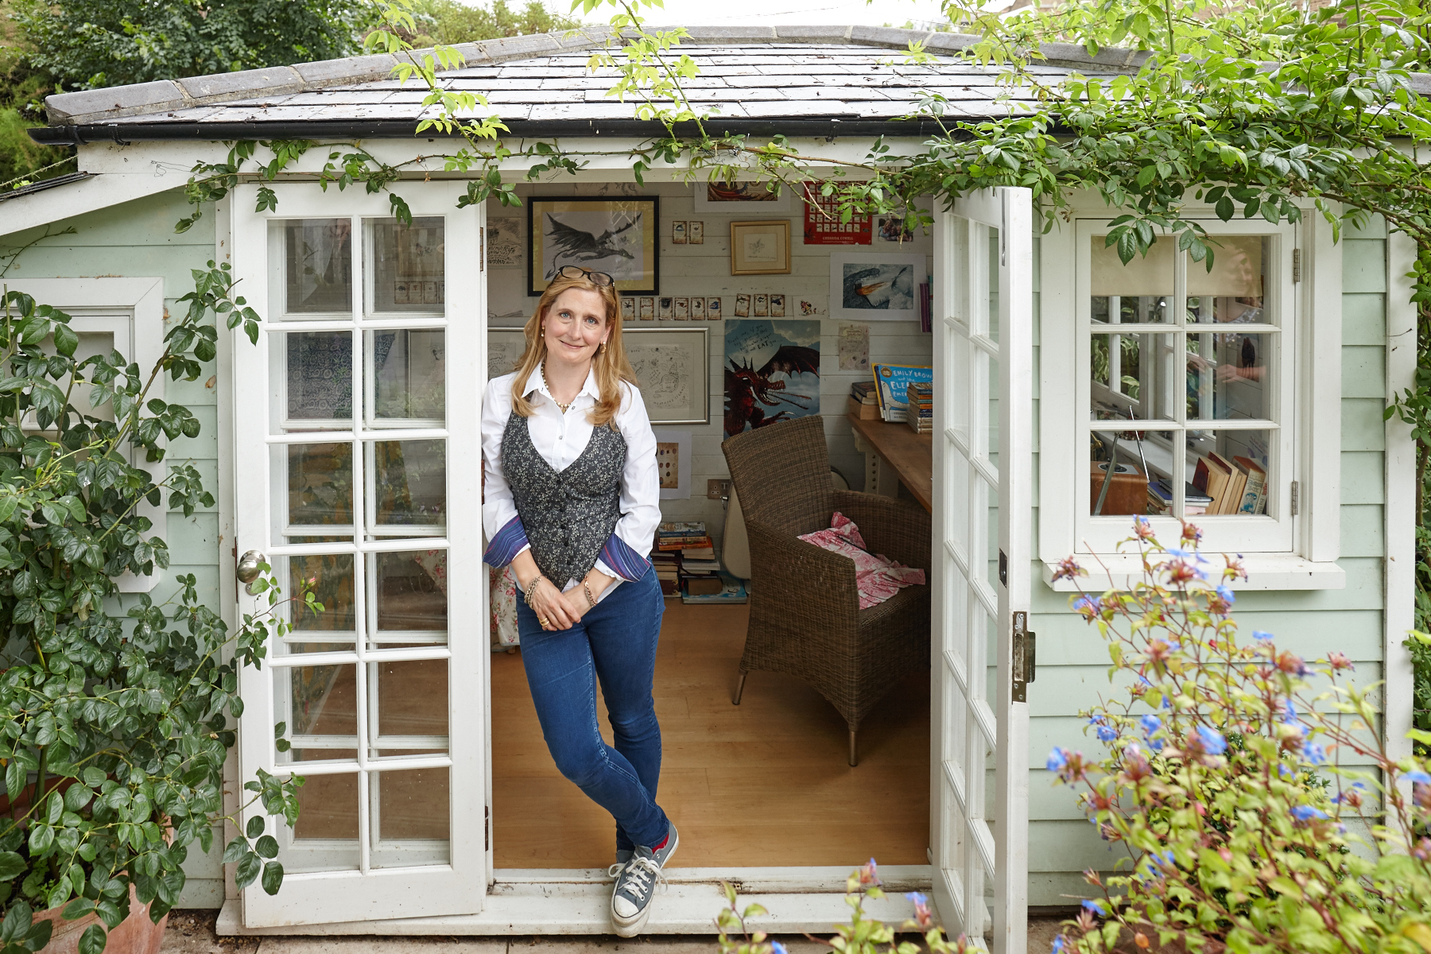

Today, BookTrust, the UK’s largest children’s reading charity, have launched a new digital hub to entertain children and families at home, packed with free books, videos, games, recipes, competitions, quizzes and much more.

From activity sheets to live drawalongs, BookTrust Home Time hosts an extraordinary menu of ideas created by leading children’s authors and illustrators, in response to the closure of schools in the UK, all designed to keep children entertained and get them reading through this time of change.

Launched by Waterstones Children’s Laureate Cressida Cowell, the hub currently includes content from BookTrust Illustrator in Residence Ed Vere and Irish Children’s Laureate Sarah Crossan and will also include new fun content and ideas from more authors every day week. Families will also be able to follow the content on social media by using #BookTrustHomeTime as well as content from leading children’s reading organisations by following #Unitedbybooks.

Diana Gerald, BookTrust CEO said:

“Families across the country are adjusting to a temporary new way of living and BookTrust are here to support and build morale in the best way we know how – reading for fun! We are proud to be able to host a free content hub to share resources, ideas and interactive activities from our own experts, along with some of the UK’s most loved authors and illustrators, with families across the country.

At BookTrust we want to get more children reading and despite these challenging times, time at home with family is a great opportunity to find inspiration in books, create fantastic new habits and perhaps uncover a new passion! ”

Waterstones Children’s Laureate Cressida Cowell said:

“As of today, millions of children and their parents will be unexpectedly at home following the closure of schools across the country. I’m a parent myself and I really empathise with families and schools facing this unsettling time in the education of so many young people, as well as the challenges of trying to juggle work and home-schooling.

I began writing about Vikings and dragons when I was nine-years old, feeling bored on my summer holiday with seemingly nothing to do. Every child out there will have fantastic ideas which could one day be the next How to Train Your Dragon. There is a world of creativity and imagination to discover from home that will bring inspiration over the coming weeks.

The wonderful community of children’s authors and illustrators has responded to the closure of schools by creating a huge selection of ideas and activities for children, parents and carers to share together – hosted on BookTrust Home Time.

Starting on Monday, from my shed, I will be sharing a series of videos including readings – from my own books, and from others – as well as drawing advice, giving some tips on creativity as well as setting a few challenges along the way. I will also be live streaming to answer questions, run drawalongs and read, beginning with a daily reading of the very first How to Train Your Dragon, as I have always found adventure, hope and kindness in Hiccup’s world. You can follow the story using #MagicIdeas.

Books, reading and creativity are magic, and we need magic more than ever during this unsettling time.”

Press Contact
For further information about BookTrust Home Time please contact:
- Emily Grigg at BookTrust: emily.grigg@booktrust.org.uk | 07533 021300
For further information about Cressida Cowell and to request interviews, please:
- Hannah McMillan at Midas PR: hannah.mcmillan@midaspr.co.uk | 07971 086649

About BookTrust
BookTrust is dedicated to getting children reading because we know that children who read are happier, healthier, more empathetic and more creative. Their early language development is supported and they also do better at school. We are the UK’s largest children’s reading charity; each year we reach 3.9 million children across the UK with books, resources and support to help develop a love of reading, because we know that reading can transform lives. We work with a variety of partners to get children excited about books, rhymes and stories, because if reading is fun, children will want to do it. Our books are delivered via health services, libraries, schools and early years practitioners, and are supported with guidance, advice and resources to encourage the reading habit. booktrust.org.uk

About the Waterstones Children’s Laureate
The Waterstones Children’s Laureate is managed by BookTrust, the UK’s largest children’s reading charity, and sponsored by Waterstones. It is awarded once every two years to an eminent writer or illustrator of children’s books to celebrate outstanding achievement in their field, and celebrates children’s literature as an art form, recognising its contribution to culture and bringing it to the attention of a wider audience.

This prestigious role was originally created by Poet Laureate Ted Hughes and author Michael Morpurgo. The ‘League of Laureates’ are the foremost representatives of children’s literature, showcasing the extraordinary and dynamic art form and its rich contribution to culture in the UK. Each Laureate brings their own passion to the prestigious role and focuses on their own particular themes to create a unique legacy.

The current Waterstones Children’s Laureate is Cressida Cowell, the international bestselling author and illustrator of the How to Train Your Dragon and The Wizards of Once series and author of the Emily Brown picture books. The previous ten Laureates are: Quentin Blake (1999-2001), Anne Fine (2001-2003), Michael Morpurgo (2003-2005), Jacqueline Wilson (2005-2007), Michael Rosen (2007-2009), Anthony Browne (2009-2011), Julia Donaldson (2011-2013), Malorie Blackman (2013-2015), Chris Riddell (2015-2017), Lauren Child (2017-2019).

About Cressida Cowell
Cressida Cowell is the number one bestselling author-illustrator of the How to Train Your Dragon and The Wizards of Once book series, and the author of the Emily Brown picture books, illustrated by Neal Layton. She has sold over 11 million books worldwide in 38 languages. How to Train Your Dragon is also an award-winning billion-dollar DreamWorks film series, and a TV series shown on Netflix and CBBC; The Wizards of Once has also been optioned for film by DreamWorks.

Cressida is an ambassador for the National Literacy Trust, a trustee for World Book Day and a founder patron of the Children’s Media Foundation. She has won numerous prizes for her books, including the Blue Peter Book Award and the Ruth Rendell Award for Championing Literacy. She grew up in London and on a small, uninhabited island off the west coast of Scotland and she now lives in Hammersmith with her husband, three children and a dog called Pigeon.

About Waterstones
Waterstones is the UK and Ireland’s leading high street bookseller with 293 bookshops, including Foyles, Hatchards, Hodges Figgis and branches in Ireland, Brussels and Amsterdam. It is the only national specialist book retailer of scale in the UK, with the average sized shop carrying a range of around 30,000 individual books and with over 200,000 titles in the largest shop. Waterstones.com | @Waterstones

About Hachette Children’s Group
Hachette Children's Group is one of the largest children's publishers in the UK, with an excellent track record in creating bestselling and award-winning books for children.

The Group aims to cater for every child, with baby and pre-school books, picture books, gift, fiction, non-fiction, series fiction, books for the school and library market and licensed publishing and comprises the imprints Hodder Children’s Books, Orchard Books, Orion Children’s Books, Little, Brown Books for Young Readers, Quercus Children’s Books, Pat-a-Cake, Wren & Rook, Franklin Watts and Wayland Books.

The Group publishes a wide range of authors, illustrators, series and licenses including: Cressida Cowell, Kes Gray, Jim Field, Jessica Townsend, Onjali Raúf, Kiran Millwood Hargrave, Matthew Syed, Bryony Gordon, David Almond, Lauren Child, Patrice Lawrence, Dermot O’Leary, Francesca Simon, Alex T. Smith, Zanib Mian, Nadiya Hussain, Giles Andreae, Piers Torday, Rainbow Magic, Beast Quest and Pokémon.

Hachette Children’s Group is also the publisher of author Enid Blyton, and the owner of Enid Blyton Entertainment.

hachettechildrens.co.uk
@hachettekids

