Under strict embargo: Thursday 7th March, 00:01 (print) 08:30 (online)
The Boy at the Back of the Class and The Colours of History win 2019 Blue Peter Book Awards
Uncovering the mysteries of colour and tales of finding your place in the world top the list for Best Book with Facts and Best Story prize
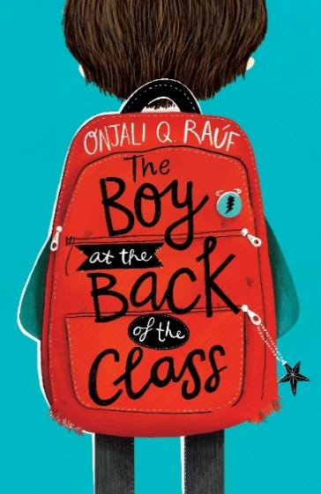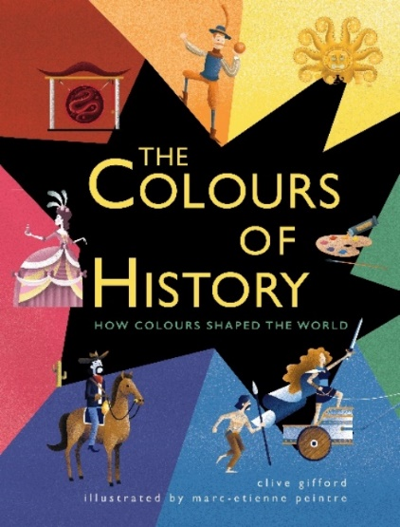
Thursday 7th March 2019 – The Boy at the Back of the Class by Onjali Q Raúf and The Colours of History by Clive Gifford, illustrated by Marc-Etienne Peintre, have been revealed as the 2019 Blue Peter Book Award winners.
Managed by BookTrust, the UK’s largest children’s reading charity, the immensely popular Blue Peter Book Awards honour amazing authors, imaginative illustrators and the best books for children, published in the last 12 months. The winning titles were voted for by over 300 children from 12 schools across the UK.
Winner of Best Story is: The Boy at the Back of the Class by Onjali Q Raúf
Onjali’s latest book, tells the story of how four classmates have a massive impact on the life of Ahmet, a boy that comes to their school as a refugee from Syria. An inspiring tale that will help children be the best they can be and realise the power of kindness.
Discussing the award Onjali Q Raúf said: "What a wonderful, surreal, and truly epic honour it is to win this wonderful award! I can hardly believe that my childhood dream of owning a Blue Peter badge one day has come true in the most unexpected way possible! I am utterly bowled over by the love and support The Boy at the Back of the Class has received not just from the marvellous Blue Peter Judges, but all the children who voted for its place as a winning title this year – Thank You."
Winner of Best Book with Facts is: The Colours of History by Clive Gifford, illustrated by Marc-Etienne Peintre
Author Clive Gifford said: “To be recognised by a show I watched and loved as a child (and still do as an adult) is a remarkable thing. I’m tickled pink! I want to thank all the children who voted for The Colours of History. And a big thank to BookTrust for the remarkable work they do. Awards like these are so important in getting across how books with facts can tell incredible and important stories and excite, inspire and entertain young minds as much as fiction.”
Illustrator Marc-Etienne Peintre commented: "I was very lucky to get to work with Clive and the Quarto team on such an interesting subject. I am extremely honoured to have won this prize, and most of all, to know that the children the book is intended for have read and enjoyed The Colours of History."
On Thursday 7th March, the winning two authors will appear on a special World Book Day edition of Blue Peter, the longest running children’s programme in the world. Also appearing on the show are our judges, award-winning author and illustrator Alex T Smith and author and UK’s number one parenting vlogger Louise Pentland.
Alex T. Smith, Author, Illustrator and Blue Peter Book Awards judge said: “It’s been an absolute pleasure to be part of the Blue Peter Book Award judging panel this year, and such a delight to work with the other judges. It was a very competitive shortlist with brilliant titles, and it was a very close call but we think the students have made a fantastic decision!”
Blue Peter editor, Matthew Peacock said: “We’ve had a fantastically strong selection of titles for the Blue Peter Book Awards 2019 and it’s great to see children from across the UK voting to decide the outcome. Congratulations go to Best Story Book winner Onjali Q. Rauf for The Boy at the Back of the Class which is such an informative and poignant tale about a subject that is very important to many children today. I’m also incredibly pleased we are able to present Clive Gifford with the award for Best Book with Facts. The Colours of History is such an original take on a history book, linking colours to amazing facts.”
Diana Gerald, CEO, BookTrust commented: “Each year the Blue Peter Book Awards is an excellent opportunity to celebrate talented authors and illustrators who create amazing books. This year was no different, the nail-biting school verdict was a very close competition, but we are delighted that Onjali and Clive took the top places - two very deserving winners who continue to encourage so many young children to read and love stories.”
Keep up-to-date with the Awards at www.booktrust.org.uk/bluepeter and on Twitter by following @BookTrust and #bluepeter

[Ends]

Press Contacts: Emily Grigg, Press Officer, BookTrust, emily.grigg@booktrust.org.uk, +44 (0)20 7801 8848
Notes to Editors
Best story shortlist
- The Boy at the Back of the Class by Onjali Q Raúf (Orion Children's Books)
- The House with Chicken Legs by Sophie Anderson (Usborne)
- The Clockwork Crow by Catherine Fisher (Firefly)
Best book with facts shortlist
- The Colours of History by Clive Gifford, illustrated by Marc-Etienne Peintre (QED Publishing)
- Professor Astrocat's Human Body Odyssey by Dr. Dominic Walliman, illustrated by Ben Newman (Flying Eye Books)
- The Element in the Room by Mike Barfield, illustrated by Lauren Humphrey (Laurence King)
Schools that took part in the judging process:
- Blaenavon Heritage Voluntary Controlled Primary School (Wales)
- Leaney Primary School (Northern Ireland)
- Glasgow Gaelic School (Scotland)
- Witton Gilbert Primary School (North East England)
- St Mary's CE Junior & Infant School (North West England)
- Reigate Primary (East Midlands)
- Prince Albert Junior and Infant School (West Midlands)
- The Priory CE School Greater (London)
- Ralph Sadleir School (South East England)
- St Just Primary School (South West England)
- The Mayflower Primary School (East of England)
- Scawby Academy (Yorkshire and The Humber)
Blue Peter is the longest running children’s programme in the world and celebrated its 60th anniversary in October 2018.
BookTrust is dedicated to getting children reading because we know that children who read are happier, healthier, more empathetic and more creative. Their early language development is supported and they also do better at school.
We are the UK’s largest children’s reading charity; each year we reach 3.4 million children across the UK with books, resources and support to help develop a love of reading, because we know that reading can transform lives.
We work with a variety of partners to get children excited about books, rhymes and stories, because if reading is fun, children will want to do it. Our books are delivered via health, library, schools and early years practitioners, and are supported with guidance, advice and resources to encourage the reading habit.
Onjali Q. Raúf is the founder of Making Herstory, an organisation mobilising men, women and children from all walks of life to tackle the abuse and trafficking of women and girls in the UK and beyond. In her spare time she delivers emergency aid convoys for refugee families surviving in Calais and Dunkirk, and supports interfaith projects. She specialised in Women's Studies at the University of Wales, Aberystwyth and Oxford University. The Boy at the Back of the Class is her first novel.
Clive Gifford is an award-winning author of more than 200 books for children and young adults. His titles published by Ivy Kids include The Human Body in 30 Seconds, Brain Twisters, and Eye Benders, winner of the 2014 Royal Society Young People’s Book Prize.
Marc-Etienne Peintre studied illustration at the Emile Cohl school in Lyon before moving to Paris where he works as an illustrator of magazines and picture books, employing a playful and offbeat style that makes strong use of colour and texture.

