Under strict embargo until 16:00 on 15 April 2019
Less than 2% of published authors and illustrators in the UK are British people of colour says new BookTrust research
British authors and illustrators of colour consistently underrepresented in publishing industry, says children’s reading charity BookTrust
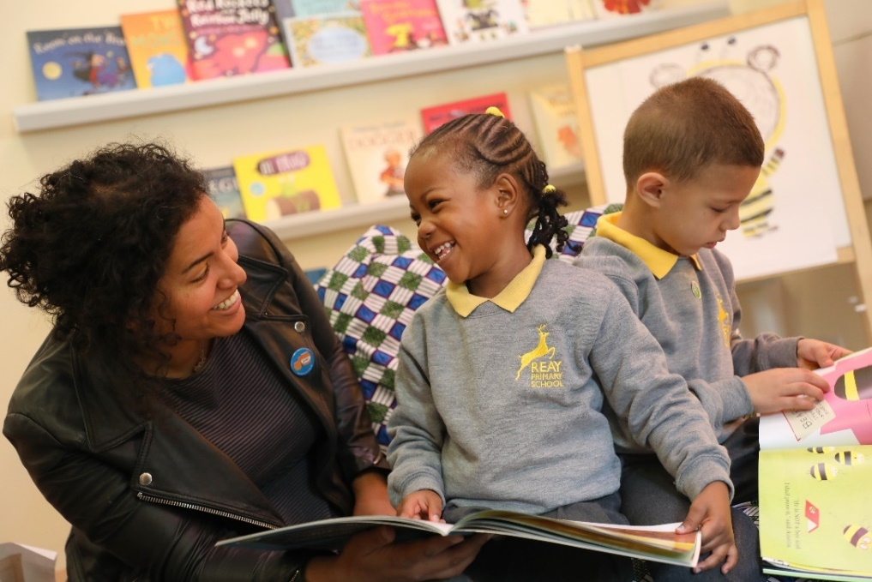
Author/illustrator Nadia Shireen on a school visit in London
15 April 2019 - BookTrust has today released findings of a groundbreaking new report into the underrepresentation of authors and illustrators of colour within children’s book publishing.
The UK’s largest children’s reading charity has found that over an 11-year period, there has been a consistent underrepresentation of British authors and illustrators of colour within the industry.
- In 2017 fewer than 6% of children’s authors and illustrators were people of colour (5.6%)
- In 2017 less than 2% of these were British people of colour (1.98%)
- Between 2007 and 2017, white children’s books creators had around twice as many books published compared to those of colour– an average of 4 books in comparison to approximately 2 books per person
Jill Coleman, Director of Children’s Books, BookTrust said: “This significant piece of research shines a light on the fact that there is a desperate lack of authors and illustrators of colour within the children’s books industry. We know there is lots of positive work happening to help level the playing field but there is still a long way to go. Children need and deserve to see themselves in books, and to have access to a rich and diverse range of voices. If they do, it can be life-changing. BookTrust Represents is a three-year initiative to support and subsidise authors and illustrators of colour to promote their work and support them to reach more readers through events in bookshops, festivals and schools, as well as offering training and mentoring for less experienced authors and illustrators. Our aim is that by 2022 we will have increased the number of authors and illustrators of colour in the UK from less than 6% to 10%.”
Sarah Crown, Director of Literature, Arts Council England, said: “This important research provides further evidence that children’s literature does not reflect the diversity of twenty-first century Britain, with writers and illustrators from Black and minority ethnic backgrounds particularly under-represented.
Sarah continued: The report highlights that the majority of the books available to readers in this country by writers and illustrators of colour are by overseas artists, shining a harsh light on just how poorly the UK is doing at developing home-grown talent. The stark findings that just 2% of children’s books creators are British people of colour is truly shocking. To help combat this, we are pleased to support BookTrust’s three-year plans to provide vital opportunities for writers and illustrators of colour across the country, with the aim of increasing the number published in the UK from less than 6% overall, to 10% by 2022.”
In her previous influential work, Dr Rudine Sims Bishop has said: “Books are sometimes windows, offering views of worlds that may be real or imagined, familiar or strange. These windows are also sliding glass doors, and readers have only to walk through in imagination to become part of whatever world has been created or recreated by the author. When lighting conditions are just right, however, a window can also be a mirror. Literature transforms human experience and reflects it back to us, and in that reflection we can see our own lives and experiences as part of the larger human experience. Reading, then, becomes a means of self-affirmation, and readers often seek their mirrors in books.” Bishop (1990)
According to BookTrust’s findings, creators of colour faced numerous barriers throughout their careers including:
- A lack of role models among both the characters in books they read and the people who created them
- Creators of colour often struggle to simply be creators without talking about their ethnicity (or issues relating to it) within or outside of their books
Many British children’s book creators taking part in the BookTrust Represents project have expressed concern that diversity in children’s publishing is just a buzzword rather than an agenda in fundamentally transforming the industry.
Author Polly Ho-Yen said: “I feel like everyone is talking about diversity in the industry now, that the awareness is more centre stage, but I feel concerned that after the noise, it might become a short-lived trend. I’m concerned that some of the actions taken feel a little tokenistic and will therefore be short-lasting.”
Author John Aggs commented: “I feel like it’s a vicious cycle. It’s like, you don’t have brown people in children’s books, so brown people don’t grow up reading children’s books or enjoying children’s books, so they don’t make children’s books, and so on and so forth.”
Author Patrice Lawrence said: “When I give author talks in schools, I know that every young person in that hall has the potential to create original, engaging and thought-provoking stories. I also know that many young people do not believe there's a place for them to tell those stories. There are no names on the book spines like theirs, no author pictures that look like them. BookTrust Represents is a chance to change that by nurturing and showcasing new talent and inspiring the next generation of creators.”
BookTrust has also partnered with Speaking Volumes and Pop Up Projects to distribute copies of the Breaking New Ground brochure alongside book packs and recommended reads to schools across the country. Breaking New Ground is a joint national partnership project between the three organisations, designed to increase the profile of British children’s writers and illustrators of colour. The brochure is the first free national resource to celebrate 100 British writers and illustrators of colour producing quality work for children and young people in the UK.
BookTrust will proactively promote these authors and illustrators in schools to help inspire future generations so that these children see reading as for them and a career in writing or illustration as something that’s achievable.
To read the research report or to find out more about BookTrust Represents and the work we will be doing alongside the publishing industry to promote and support British writers and illustrators of colour visit booktrust.org.uk/booktrustrepresents
[Ends]
Press Contacts: Sinéad Gosai, Press Manager sinead.gosai@booktrust.org.uk, +44 (0)20 7801 8849
For Arts Council England related queries, please contact: Nisha Emich, Communications Officer, Arts Council England, 0207 268 9563 Nisha.Emich@artscouncil.org.uk
Notes to Editors
In addition, the research also found
- Women of colour are more likely to be published than men of colour (65% to 35%)
- There was a positive trend in the percentage of creators of colour published between 2007 and 2015 but a downturn between 2015 and 2017
- Unique titles by people of colour were more likely to have originally been published outside of the UK, compared to those by their white counterparts
- Creators of colour are more likely than white creators to self-publish children’s books, which is especially true for British children’s books creators of colour: one-third of their unique titles (31.59%) were self-published
BookTrust would like to thank Arts Council England for the continued support with this project and all of our work to inspire a love of reading in children. We’d also like to extend our gratitude to University College London and Dr Melanie Ramdarshan Bold, Senior Lecturer/Associate Professor at University College London for all the work on the research and the support in helping to get this project off the ground.

BookTrust is dedicated to getting children reading because we know that children who read are happier, healthier, more empathetic and more creative. Their early language development is supported and they also do better at school.
We are the UK’s largest children’s reading charity; each year we reach 3.4 million children across the UK with books, resources and support to help develop a love of reading, because we know that reading can transform lives.
We work with a variety of partners to get children excited about books, rhymes and stories, because if reading is fun, children will want to do it. Our books are delivered via health, library, schools and early years practitioners, and are supported with guidance, advice and resources to encourage the reading habit. booktrust.org.uk
The Arts Council is the national development body for arts and culture across England, working to enrich people’s lives. We support a range of activities across the arts, museums and libraries – from theatre to visual art, reading to dance, music to literature, and crafts to collections. Great art and culture inspires us, brings us together and teaches us about ourselves and the world around us. In short, it makes life better. Between 2018 and 2022, we will invest £1.45 billion of public money from government and an estimated £860 million from the National Lottery to help create these experiences for as many people as possible across the country. www.artscouncil.org.uk

