Celebrating 20 Years of the Waterstones Children’s Laureate

Quentin Blake | Anne Fine | Michael Morpurgo | Jacqueline Wilson | Michael Rosen Anthony Browne | Julia Donaldson | Malorie Blackman | Chris Riddell | Lauren Child

The Waterstones Children’s Laureate – managed by BookTrust, the UK’s largest children’s reading charity – will mark its 20th anniversary this year with celebrations from February to June 2019. Originally created by Poet Laureate Ted Hughes and author Michael Morpurgo, the Children’s Laureate is awarded once every two years to an eminent children's book writer or illustrator to honour outstanding achievement in their field.

Across 20 years, ten Laureates have been appointed, encompassing all genres of children’s literature – illustration, poetry, picture books, YA and everything in between – and introduced millions of children to an extraordinary world of creativity. The ‘League of Laureates’ are the foremost representative of children’s literature, showcasing the extraordinary and dynamic artform and its rich contribution to culture in the UK.

United by a shared desire to ignite imaginations and reading for pleasure, each of the Laureates have also brought their own passion to the position: from promoting the power of illustration and encouraging reading aloud, to supporting accessibility for disabled children and championing the invaluable role of libraries – and much more.

On 10 May 1999, Quentin Blake was appointed as the inaugural Children’s Laureate and presented with the now iconic silver medal by the Princess Royal. The current Waterstones Children's Laureate for 2017-2019 is Lauren Child, the multi-award-winning, bestselling writer and artist, and creator of characters such as Clarice Bean, Ruby Redfort and Charlie and Lola.

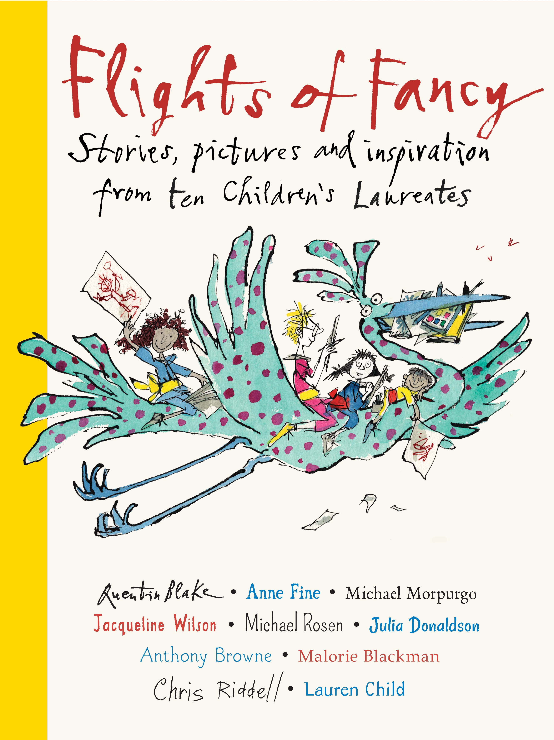
As part of the celebrations, Walker Books will publish a beautiful gift anthology Flights of Fancy: Stories, pictures and inspiration from ten Children's Laureates (7 February 2019, Hardback) by the Laureates, in partnership with BookTrust. Brimming with inspirational anecdotes, imaginative creations and incredible illustration, Flights of Fancy will be treasured by anyone with a passion for children’s books and have children picking up their pens and pencils, eager to start their very own creations.

At Southbank Centre’s Imagine Children’s Festival (16 February), Jacqueline Wilson, Malorie Blackman and Chris Riddell will give a glimpse behind the scenes of the League of Laureates, and a journey into some of their most loved stories and characters. At Oxford Literary Festival (7 April), Michael Morpurgo will share the origins of the Laureate, with the celebrations culminating with an event at Hay Festival 2019. Puffin’s hugely successful webcast for schools – Puffin Virtually Live – will also celebrate the anniversary with two special webcasts in the spring and summer term.

About the Waterstones Children’s Laureates:

Quentin Blake (1999 – 2001)
Best known for his collaborations with some of the leading writers in children's books, Quentin Blake has an unmistakable drawing style. Promoting illustration was a key focus for Quentin's time as Laureate. He conceived the idea for the House of Illustration, the world's first centre dedicated to the art of illustration in all its forms. Quentin also selected work for the first Children's Laureate exhibition Tell Me A Picture (also published as a book), held at the National Gallery in 2001. The exhibition comprised 26 pictures by artists and illustrators, each illustrating a different letter. Quentin also produced The Laureate's Party, an anthology celebrating 50 of his favourite children's books; Words and Pictures, a visual biography exploring the 'challenges and opportunities of illustration'; and recorded his own experiences in Laureate's Progress, which he called 'a kind of diary with pictures'.

Anne Fine (2001 – 2003)
Anne Fine writes for both children and adults and her interest in politics and social issues comes across in many of her books. As Children's Laureate, Anne campaigned to promote the importance of children's reading and to raise the profile of libraries. She compiled three poetry anthologies (A Shame to Miss) and launched the My Home Library scheme, encouraging children to build their own libraries at home, for which more than 100 artists and cartoonists provided original bookplate designs. Anne also focused on supporting children with visual impairment, which since developed into a postal library of Braille picture books called ClearVision.

Michael Morpurgo (2003 – 2005)
Sir Michael Morpurgo is an award-winning writer who has written scores of imaginative and suspenseful books for children. As Children's Laureate, Michael toured extensively telling his stories to teachers, parents and children to show them that literature comes before literacy, encouraging all children 'to discover and rediscover the secret pleasure that is reading, and to begin to find their voice in their own writing'.

Jacqueline Wilson (2005 – 2007)
Jacqueline's sensitive understanding of modern children, the way they live and the problems they encounter, together with her sense of humour, have made her an extremely popular author who continues to make it on to the bestsellers' lists. During her time as Laureate, Jacqueline worked with BookTrust to promote a love of books and reading amongst children and their carers as well as developing the best-selling book Great Books to Read Aloud as part of a campaign to encourage parents, carers and teachers to read aloud to children. Jacqueline also toured extensively, speaking to over 40,000 children and adults all over the UK and Ireland.

Michael Rosen (2007 – 2009)
Michael Rosen is one of the best-known figures in the children's book world, renowned for his work as a poet, performer, broadcaster and scriptwriter. As Children’s Laureate, Michael created a 20 point plan to make access to books for everyone a priority and a set of policies to put reading books at the heart of the school curriculum. Championing poetry, he created the Perform a Poem website for primary schools to encourage pupils to write, choose and perform poems, toured The A to Z of Poetry and supported the British Library exhibition on 250 years of poetry for children, Twinkle Twinkle Little Bat.

Anthony Browne (2009 – 2011)
Anthony Browne is an internationally acclaimed author and illustrator of children's books, blending near-photographic realism with fantastical, surreal touches and ingenious visual puns. As Children's Laureate, Anthony promoted the importance of picture books and children's illustration. He was keen to encourage children to be creative and use their imaginations, and to support the development of visual as well as verbal literacy. He went on to create The Picture Book project – a collaboration between Seven Stories and Action for Children – and developed the exceptionally fun Shape Game for children to play at home or in the classroom.

Julia Donaldson (2011 – 2013)
Julia Donaldson has worked with many different illustrators and written over a hundred books and plays for children and teenagers, in which her love of song and rhyme shines through. While Children's Laureate, Julia encouraged children to act and read loud an anthology called Poems to Perform, a collection of poems which could be recited by more than one voice, and a series of 60 short classroom plays designed to help children in primary school become more confident and expressive readers. She also used her role to raise the profile of stories for deaf children, as well as championing the invaluable role of libraries in the community through a six-week library tour which took her from the Highlands to Penzance, and spoke to politicians about the damaging impact of on children of library closures.

Malorie Blackman (2013 – 2015)
Malorie Blackman is acknowledged as one of today's most imaginative and convincing writers for young readers, who effortlessly addresses social and racial issues in her books. During her time as Waterstones Children's Laureate, Malorie championed writing for young people and curated the first-ever Young Adult Literature Convention, a ground-breaking project that celebrated its fifth year in 2018. She also ran a nationwide creative writing competition for teens called Project Remix, inspired by the growth of online fandom including fanfiction and fan art, and created a book called Love Hurts to showcase other YA authors.

Chris Riddell (2015 – 2017)
Chris Riddell is a prolific writer and illustrator whose work is familiar to both children and adults. He is known especially for his distinctive line drawings with their clever caricature, fascinating detail and often enchanting fantasy elements. Chris charted the progress of his Laureateship through daily online drawings on The Laureate Log, created visual resources for schools a part of his Words Need Pictures project, promoted daily doodling and travelled the length and breadth of the country as ‘The Doodler’, leading live drawing events.

Lauren Child (2017 – 2019)
Lauren Child is a multi-award-winning, bestselling writer and artist whose books are known and loved the world over. She is the creator of characters including Clarice Bean, Ruby Redfort and Charlie and Lola. Lauren launched her Laureateship with a campaign encouraging creativity, Staring into Space, which inspired children to take a moment out of their day to ‘switch off’ and daydream, allowing ideas space to emerge and play. Lauren has also curated the Drawing Words exhibition with the British Council, celebrating 10 illustrators whose word will be toured internationally. The exhibition was inspired by Magic Pencil, which was first curated by Quentin Blake.

– Ends –

For further information please contact Hannah McMillan at Midas Public Relations: hannah.mcmillan@midaspr.co.uk | 020 7361 7860

About BookTrust
BookTrust is dedicated to getting children reading because we know that children who read are happier, healthier, more empathetic and more creative. Their early language development is supported and they also do better at school. We are the UK’s largest children’s reading charity; each year we reach 3.4 million children across the UK with books, resources and support to help develop a love of reading, because we know that reading can transform lives. We work with a variety of partners to get children excited about books, rhymes and stories, because if reading is fun, children will want to do it. Our books are delivered via health, library, schools and early years practitioners, and are supported with guidance, advice and resources to encourage the reading habit. booktrust.org.uk

About Waterstones
Waterstones is the UK and Eire’s leading high street bookseller with 285 shops. It employs over 3,000 booksellers. Waterstones is the only national specialist book retailer of scale in the UK, with the average sized shop carrying a range of around 30,000 individual books and with over 200,000 titles in the largest shop.

About Walker Books
Home to books for all ages, Walker Books publishes many award-winning authors, illustrators, and literary franchises including Anthony Horowitz, Cassandra Clare, Lucy Cousins, Guess How Much I Love You by Sam McBratney and Anita Jeram, Anthony Browne, Patrick Ness, and Where’s Wally? by Martin Handford. Walker Books is part of the vibrant international Walker Books Group that includes Walker Books Australia; Candlewick Press in America and its new division, Walker Books US; and Walker Productions. The Walker Books Group enjoys a unique ownership structure which includes employees from around the world and more than 150 long-term authors and illustrators. Walker is the world’s leading wholly independent publisher of English-language children’s books.

About Puffin Books, Penguin Random House UK
Puffin is an imprint of Penguin Random House, the world’s number one publisher. Penguin Random House champions authors, shaping and sharing writing that sparks thoughts, dreams, conversations and learning.
We are a vibrant community of publishing houses, representing distinguished publishing histories marked by unparalleled success. We are a home to all kinds of authors. From the best new fiction or picture book writers, to political commentators, trailblazing entrepreneurs, health experts and bold illustrators, we enable talented people from all walks of life to tell their stories – and we make sure they are heard. We sell and license books in over 120 countries, connecting great books with a growing and global audience. We bring words to life.
For more information, please visit our website www.penguin.co.uk

