Embargoed until: Thursday 15 August 00:01
BookTrust reveals stellar speaker line up for training events
Children’s charity kicks off training sessions for aspiring authors and illustrators of colour
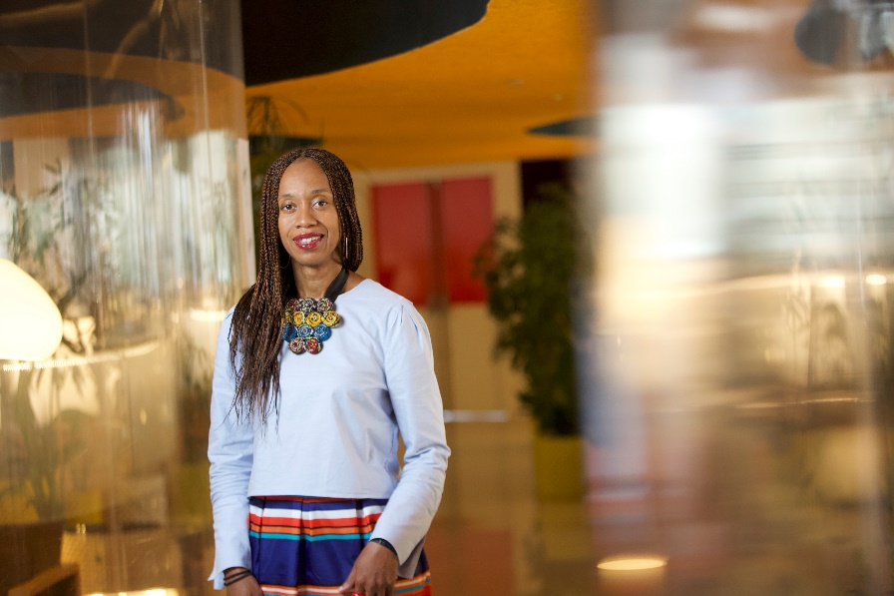
Joy Francis of Words of Colour, is one of the speakers
15th August 2019 - BookTrust today announces the lineup for its first round of training sessions, following the launch of BookTrust Represents, a project to help promote and develop children's authors and illustrators of colour.
The workshops are led by award-winning author of Orangeboy, Patrice Lawrence, the incredible Joy Francis of Words of Colour, the powerhouse behind BME PR Pros Elizabeth Bananuka, agents Davinia Andrew-Lynch and Penny Holroyde-Cartey and Society of Authors very own Jo McCrum, as well as a host of other authors and industry experts.
The free one-day training events will be held in Bradford and London in September, with aspiring creatives getting the chance to learn about the ins and outs of the industry, from growing their profile, building their confidence, how to run a school visit, working with agents, how to source funding opportunities and tips and tricks for sustaining a career in children’s books. These taster sessions will be followed by further free in-depth topic-specific workshops for aspiring children’s authors and illustrators of colour over the next two years.
Jill Coleman, Director of Children’s Books at BookTrust said: “These events are just the start for BookTrust Represents. There is a host of untapped emerging talent out there that we want to help harness and grow. We want aspiring authors and illustrators to learn and develop, and what better way to do that than from those who have come before them. These training and mentoring sessions will give them a much-needed insight into the industry and a taster of the in-depth workshops we will be offering over the next two years.”
BookTrust Represents is a three-year initiative led by the UK’s largest children’s reading charity to support authors and illustrators of colour to promote their work and reach more readers through events in bookshops, festivals and schools, as well as offering training and mentoring for less experienced authors and illustrators. BookTrust’s aim is that by 2022, the number of authors and illustrators of colour in the UK will have increased from less than 6% to 10%.
Elizabeth Bananuka, BME PR Pros founder and one of the workshop mentors said: “BookTrust's research earlier this year highlighted the shocking lack of published authors and illustrators of colour in the UK, which isn't to say they don't exist, just that they don't necessarily have access to the industry. In fact, we’re overflowing with an enormous amount of homegrown talent in Britain which BookTrust’s training workshops will help to harness; offering aspiring and established creatives practical, tangible tips and advice for building connections, sourcing funding and developing and sustaining their careers as the children’s book creators of the future. I’m incredibly excited to be leading one of the sessions to help get them started on their next chapter.”
For more information or to register for your place:
Click here for Bradford on Saturday 21 September.
Click here for London on Saturday 28 September.
[Ends]
Press Contacts: Sinéad Gosai, Press Manager sinead.gosai@booktrust.org.uk, +44 (0)20 7801 8849
Notes to editors
Bradford Saturday 21 September
The Publishing industry: A Case Study start to finish - Patrice Lawrence (Author)
Working with an agent: For Illustrators - Penny Holroyde-Cartey (Agent)
Working with an agent: For Writers - Davinia Andrew-Lynch (Agent)
Confidence Building for creatives - Claire Malcolm (CEO New Writing North)
Dealing with the Public + Growing Your Profile - Elizabeth Bananuka
Entrepreneurship: Funding Opportunities – Rhoda Baxter (Society of Authors)
Introduction to school visits - Chitra Soundar (Author)
The Publishing Industry: How to stay published – Bali Rai (Author)
London Saturday 28 September
The Publishing industry: A Case Study start to finish – tbc (Author)
Working with an agent: For Illustrators - Sally-Anne Sweeney (Agent)
Working with an agent: For Writers - Davinia Andrew-Lynch (Agent)
Confidence Building for creatives - Joy Francis (Exec Director Words of Colour)
Dealing with the Public + Growing Your Profile - Elizabeth Bananuka
Entrepreneurship: Funding Opportunities - Jo McCrum (Society of Authors)
Introduction to school visits - Chitra Soundar (Author)
The Publishing Industry: How to stay published - Candy Gourlay (Author)

To find out more about the work BookTrust is doing alongside the children's book industry to promote and support British writers and illustrators of colour visit booktrust.org.uk/booktrustrepresents
BookTrust is dedicated to getting children reading because we know that children who read are happier, healthier, more empathetic and more creative. Their early language development is supported and they also do better at school.
We are the UK’s largest children’s reading charity; each year we reach 3.4 million children across the UK with books, resources and support to help develop a love of reading, because we know that reading can transform lives.
We work with a variety of partners to get children excited about books, rhymes and stories, because if reading is fun, children will want to do it. Our books are delivered via health, library, schools and early years practitioners, and are supported with guidance, advice and resources to encourage the reading habit. booktrust.org.uk

