Monkeying around with reading: Reception children in England given free books
700,000 free copies of Little Monkey given out for BookTrust’s Time to Read campaign
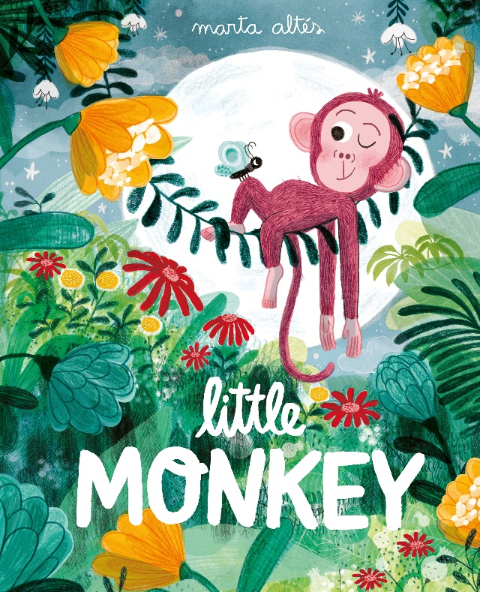
8th May 2018 – School starters in England will receive their very own copy of the book Little Monkey this September as part of BookTrust’s Time to Read campaign.
Now in its third year, the Time to Read campaign from the UK’s largest children’s reading charity encourages families to make time to read together, share stories every day and find the fun in reading.
This funny and empowering picture book tells the tale of a little monkey in a big troop, in an even bigger jungle. Monkey has enough of missing out, of being too small for big adventures, so she bravely heads off all alone to climb to the top of the tallest tree in the jungle. Written and illustrated by the renowned Marta Altés, Little Monkey (Pan Macmillan) shows us that the world is a big, wild and wonderful place where anything is possible.
BookTrust Chief Executive Diana Gerald said: “Children are more likely to read if they’re having fun with stories and we couldn’t think of a more colourful, enjoyable and entertaining book. At BookTrust we want to ensure all children have access to books and enjoy the adventure and escapism that comes with getting lost in a good book. Little Monkey is beautifully illustrated and brilliant to read aloud.”
A panel of experts chose Little Monkey because of its fun, detailed illustrations and great message that no matter how small you are, or how big the world seems, you can accomplish anything if you put your mind to it. It’s perfect for reading together and the challenges Monkey faces of being too small and not wanting to miss out are easily relatable for little children.
Marta Altés, author and illustrator of Little Monkey said: “I'm so excited and it's such an honour to work with BookTrust on their Time to Read campaign. It's wonderful that Little Monkey will be used to start little people on their reading journey. I hope that Little Monkey and her adventures in the jungle not only inspire a love of reading but also remind children that even when you're small you can do amazing things!”
Every reception age child in England will start receiving Little Monkey at school from September. The book is delivered inside a special Time to Read pack that each child gets to keep and take home. Inside each pack is a message for families about the importance of shared reading, alongside practical tips and advice to help them bring the story to life at home. booktrust.org.uk/timetoread
Belinda Ioni Rasmussen, Publisher at Macmillan Children's Books said: "We are absolutely delighted to be working with BookTrust, supporting this wonderful and important initiative to ensure that a love of reading goes beyond the classroom walls and stays with a child for life. Marta Altes' Little Monkey celebrates the amazing things we can achieve if we put our minds to it, regardless how big or small we are, making it a perfect and encouraging read for children who are just starting their school lives. We hope that Little Monkey's plucky and adventurous spirit will be embraced by the children as they embark on a lifetime of reading for pleasure."
[Ends]
Press Contacts: Sinéad Gosai, Press Officer, BookTrust, sinead.gosai@booktrust.org.uk, +44 (0)20 7801 8849
Notes to Editors
BookTrust is the UK’s largest children’s reading charity. We work to inspire a love of reading in children because we know that reading can transform lives. Each year we reach 3.4 million children across the UK with books, resources and support to help develop a love of reading. Every parent receives a BookTrust book in their baby’s first year. Our books are delivered via health, library, schools and early year’s practitioners, and are supported with guidance, advice and resources to encourage the reading habit. Reading for pleasure has a dramatic impact on educational outcomes, well-being and social mobility, and is also a huge pleasure in itself. We are committed to starting children on their reading journey and supporting them throughout. booktrust.org.uk
Marta Altés is the award-winning creator of I am an Artist!, My Grandpa, The King Cat and Little Monkey. She studied her degree in Graphic Design in Barcelona and then moved to the UK to study for an MA in Children's Book Illustration at Cambridge School of Art. She graduated in 2011 and published her first picture book with Macmillan Children's Books in 2013. Since then she has won numerous prizes for her work. As well as publishing, Marta also illustrates for French and Spanish magazines, works with various advertising agencies and has run illustration workshops at the National Portrait Gallery.
Pan Macmillan is the UK general book publishing arm of the Macmillan Group, which operates in over 70 countries. Its imprints include Macmillan, Mantle, Pan, Picador, Bluebird, Boxtree, Sidgwick & Jackson, Bello, Tor, Macmillan Children’s Books, Campbell Books, Kingfisher, Two Hoots and Macmillan Digital Audio. Pan Macmillan was named Publisher of the Year at The Bookseller Industry Awards in May 2015, and again in May 2017.

