‘Keeeep reading’ says Strictly Star Ore Oduba, the face of BookTrust’s new story time video
BookTrust gifts 450,000 copies of A Busy Day for Birds by Lucy Cousins to youngsters
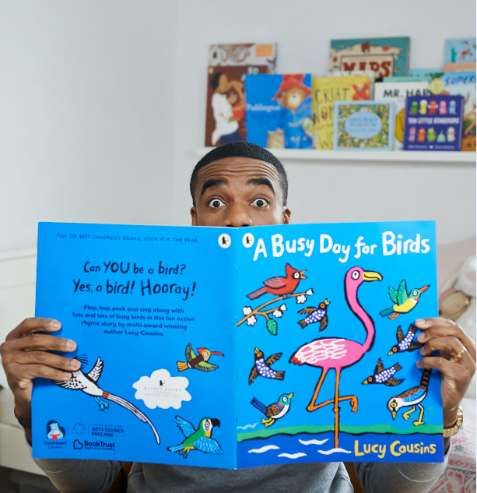
Photographer credit Jamie Gardiner
Monday 21St May - BookTrust has partnered with popular TV presenter, new dad and Strictly Winner Ore Oduba, who playfully reads a new story time video bringing this year’s National Bookstart Week title A Busy Day for Birds to life.
BookTrust, through its partnership with Walker Children’s Books, will gift 450,000 hard copies of Lucy Cousins’ A Busy Day for Birds to children across the country through National Bookstart Week (4-10 June). This year, BookTrust will be giving over 32,000 packs to outreach partners across the country, including 10,250 packs to Food Banks and 1,600 packs to Women’s Refuges.
Ore Oduba said: “I’m delighted to be taking part in BookTrust’s National Bookstart Week. Having recently had our son, my wife and I love reading to him - even at such an early age - as it’s so lovely for all of us to spend time together. Shared reading is also a good way to stimulate kids, creating images in their mind that ultimately enable them to express themselves so much better.”
National Bookstart Week is an annual celebration of BookTrust’s flagship reading programme, Bookstart. Since 1992, BookTrust has gifted over 34 million books to children across the country through Bookstart. Children in England and Wales receive Bookstart packs at two key stages before they start school.
Diana Gerald, Chief Executive of BookTrust said: “A Busy Day for Birds is a brilliantly entertaining book, we are thrilled it’s been chosen as our National Bookstart Week title. Ore’s playful and enchanting reading really does bring the book to life and shows parents that reading can be fun and light hearted. We hope families across the country enjoy snuggling down with their copy of the book imagining they are different birds!”
This year’s National Bookstart Week theme is ‘Bookstart Bird Boogie’ and from Monday 4th – Sunday 10th June there will be hundreds of free events around the country for babies, toddlers, pre-schoolers and their families, at libraries, children centres, nurseries and bookshops.
Lucy Cousins, author of A Busy Day for Birds said: “I’m thrilled to know that A Busy Day for Birds will take flight with the wonderful Bookstart programme! It’s so important for all young children to have access to the joy that reading can bring and I hope that families up and down the country enjoy sharing this story together!”
A Busy Day for Birds was chosen as this year’s National Bookstart Week title for its bright and colourful illustrations, fun, rhyming text and for its ability to work well in both group and one-to-one readings. Previous titles include Everybunny Dance! By Ellie Sandall, A Hole in the Bottom of the Sea, adapted by Jessica Law and illustrated by Jill McDonald, Rumble in the Jungle by Giles Andreae and illustrated by David Wojtowycz and Super Duck by Jez Alborough.

Mara Alperin, Senior Editor, Walker Books said: "We’re delighted that Lucy’s beautiful book has been chosen for the Bookstart programme. With vibrant colours and a wonderful read-aloud text, A Busy Day for Birds is the perfect book for a parent and child to share together. Thank you to BookTrust for their great work giving out books and inspiring a love of reading!"
ENDS
Press Contacts: Bethan Phillips, Press Officer, BookTrust, Bethan.phillips@booktrust.org.uk, 020 7801 8848
Notes to Editors
BookTrust is the UK’s largest children’s reading charity. We work to inspire a love of reading in children because we know that reading can transform lives. Each year we reach 3.4 million children across the UK with books, resources and support to help develop a love of reading. Every parent receives a BookTrust book in their baby’s first year. Our books are delivered via health, library, schools and early year’s practitioners, and are supported with guidance, advice and resources to encourage the reading habit. Reading for pleasure has a dramatic impact on educational outcomes, well-being and social mobility, and is also a huge pleasure in itself. We are committed to starting children on their reading journey and supporting them throughout. booktrust.org.uk
Watch the full video here
ABOUT WALKER BOOKS UK
Home to books for all ages, Walker Books UK publishes many award-winning authors, illustrators and brands including Anthony Horowitz, Cassandra Clare, Lucy Cousins, Anthony Browne, Polly Dunbar, Patrick Ness and Where’s Wally? Walker Books UK is part of the vibrant international Walker Books Group that includes Candlewick Press in America, Walker Books Australia, the Walker Group Licensing division, and Walker Productions, developing Walker content for other media platforms, including Hank Zipzer for BBC. The Walker Books Group enjoys a unique ownership structure which includes all of its employees worldwide and more than 150 authors and illustrators. Walker is the world’s leading wholly independent publisher of English-language children’s books.
Further information can be found at www.walker.co.uk

Lucy Cousins is the multi-award-winning creator of Maisy. Her unique titles fascinate toddlers with their child-like simplicity, bold outlines and vivid colours. "Maisy does things that children all over the world do," Lucy Cousins says of her superstar mouse. "The way she dresses, the way she acts, are typical of children all over the world." Lucy Cousins works from her home in Hampshire, England. Other titles include the Smarties Book Prize-winner Jazzy in the Jungle; Hooray for Fish! – which has appeared in animation in Japan; the bestselling New York TimesTop 10 Best Illustrated Children's Book Yummy; the critically acclaimed Peck Peck Peck, which won Best Picture Book in the Booktrust Best Book Awards, as well as the British Book Design and Production Award in the Children's Trade category; and more recently A Busy Day for Birds.

