UNDER STRICT EMBARGO UNTIL: WEDNESDAY 19th SEPTEMBER 00:01
Fake news not fooling kids who read, says BookTrust and leading developmental psychologist
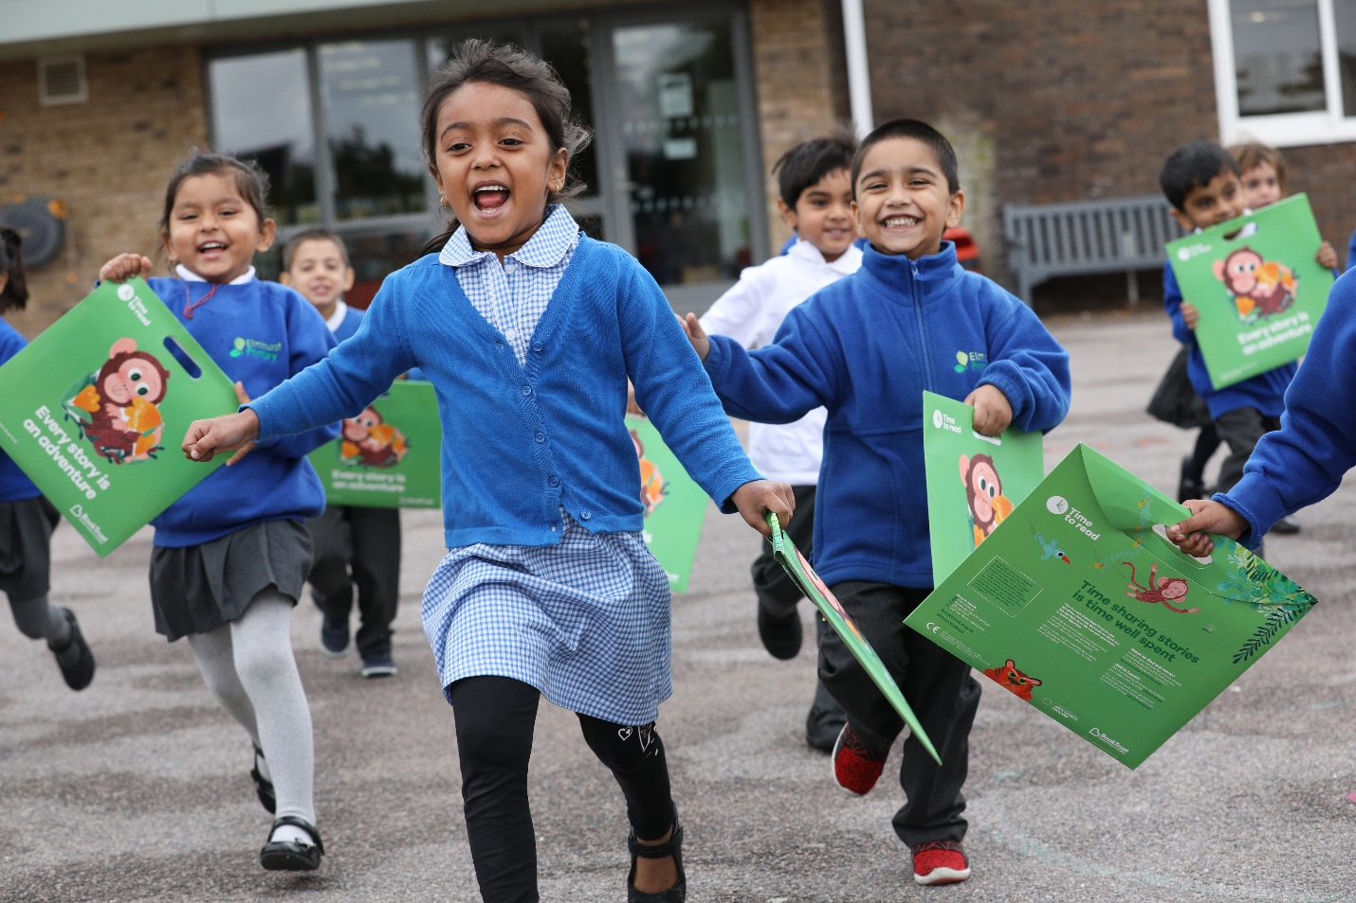
Children at Elmhurst Primary School in London receiving their Time to Read packs
Tuesday 18th September – Today, BookTrust, as part of their Time to Read campaign argues the importance of visual literacy for children’s development. The UK’s largest children’s reading charity, alongside developmental psychologist Emma Kenny argues that understanding imagery and identifying visual clues in illustrated books helps young children to make sense of wider topics as they get older.
In a world where advertising becomes ever more pervasive and fake news continues to infiltrate news sources at an alarming rate, children can often struggle to tell the difference between what’s real and fake. Having the ability to understand context and symbolism and decode information is crucial for young people if we want them to become more active learners and help arm them against the barrage of fake news.
BookTrust believes that reading and sharing stories is vital for helping children think for themselves and encourage wider discussions. Illustrated books help children to develop free association, to understand inference and to create their own narratives rather than accepting things at face value.
This September, as part of its annual Time to Read Campaign, BookTrust, Emma Kenny and leading children’s illustrators including Chris Riddell, Sarah McIntyre of the Pictures Mean Business campaign and Waterstones Children’s Laureate, Lauren Child, are asking families to recognise the importance of illustrated books and to take time to explore reading and sharing stories together to help children to understand the world around them, enable them to figure out fact from fiction and allow them to become more independent thinkers.
Developmental psychologist Emma Kenny says: “I am thrilled to be working with BookTrust on their Time to Read campaign. Children’s brains start to develop at an early age, so it’s important we introduce them to activities that will stimulate them and help them to grow. Picture books are a subtle way to introduce ideas to children that will encourage them to start thinking independently and help them learn to understand subtext and meaning. Now more than ever, we need to arm children with the skills they need to figure out what’s going on around them and I’d urge parents across the country to pick up a picture book and get decrypting with your children.”
BookTrust, the UK’s largest children’s reading charity is giving away over 700,000
copies of Little Monkey by author and illustrator Marta Altés to every reception aged child in England. Little Monkey is a great book to get kids excited about reading. It’s filled with beautiful illustrations and lots of colourful pictures that give young readers hints to help encourage them to think outside the box to understand the unwritten dangers in the story.
Diana Gerald, CEO of BookTrust says: “Illustrated books are a wonderful resource for children to help them develop key skills, build their confidence and grow their imagination. Visual clues in the story can help them to decipher meaning and encourage them to engage with the narrative on their own terms, beyond just the words. Little Monkey is a heartwarming tale about a brave and curious monkey who is fed up of being told she’s too small to go on adventures. Something that many young ones will no doubt relate to. It’s the perfect picture book for families to have fun with this autumn.”
For more information on BookTrust and the Time to Read Campaign visit booktrust.org.uk
[Ends]
Press Contacts: Sinéad Gosai, sinead.gosai@booktrust.org.uk, +44 (0)20 7801 8849 or Bethan Phillips, bethan.phillips@booktrust.org.uk +44 (0)20 7801 8848
Notes to Editors
BookTrust’s Time to Read campaign is currently in its third year. Every reception aged child in England will start receiving Little Monkey at school from September. The book is delivered inside a special Time to Read pack that each child gets to keep and take home. Inside each pack is a message for families about the importance of shared reading, alongside practical tips and advice to help them bring the story to life at home. booktrust.org.uk/timetoread.
Waterstones Children’s Laureate, Lauren Child said: "Children's books are so sophisticated, because the words are telling you one thing and the pictures take it to a whole different level. When I look at the illustration in John Burningham’s book Granpa, which is about death, it says everything without any words. I think it’s one of the most beautiful illustrations I‘ve ever seen. The hollowness in that child, the emptiness and the looking at the bigness of that emptiness in the chair. It’s so incredibly powerful and it’s a very beautiful piece of art. And the fact that he has created something that child who can’t read can understand, because children are visual beings and artists as soon as they are born, just like Picasso said, they know how to make marks and they know how to read pictures. We forget sometimes just how important a visual image is, because it speaks to everyone.”
Author and Illustrator Chris Riddell said: "I love books with lots and lots of pictures in them. It was how I learned to read for pleasure. I found a book with an intriguing picture on the cover and lots of even more intriguing pictures inside. I used the pictures like a key to unlock the book and find the story it contained. It felt wonderful! If books are doors, pictures are the keys."
Visual literacy is the ability to comprehend and create images in a variety of media in order to communicate effectively.
Research
- Illustrated books are a useful resource in helping to develop children’s visual literacy which helps improve several key skills including creativity, confidence and imagination.
- These types of books also aid children in play as they take information they remember from the story and act it out, so the story becomes more interactive. Drama engages the so many elements - the intellect, the emotions, the imagination, and the body – and it develops socially useful skills and knowledge. Personal qualities such as confidence, creative thinking, enquiry, effective participation, tolerance, motivation, managing feelings, an ability to work in teams, and empathy for others are developed through drama.
BookTrust is dedicated to getting children reading because we know that children who read are happier, healthier, more empathetic and more creative. Their early language development is supported and they also do better at school.
We are the UK’s largest children’s reading charity; each year we reach 3.4 million children across the UK with books, resources and support to help develop a love of reading, because we know that reading can transform lives.
We work with a variety of partners to get children excited about books, rhymes and stories, because if reading is fun, children will want to do it. Our books are delivered via health, library, schools and early years practitioners, and are supported with guidance, advice and resources to encourage the reading habit. booktrust.org.uk

Serrurier-Zucker & Gobbé-Mévellec, 2014
Sinclair et al., 2009

