‘Boredom and staring into space must be allowed’ says Lauren Child at BookTrust NI event
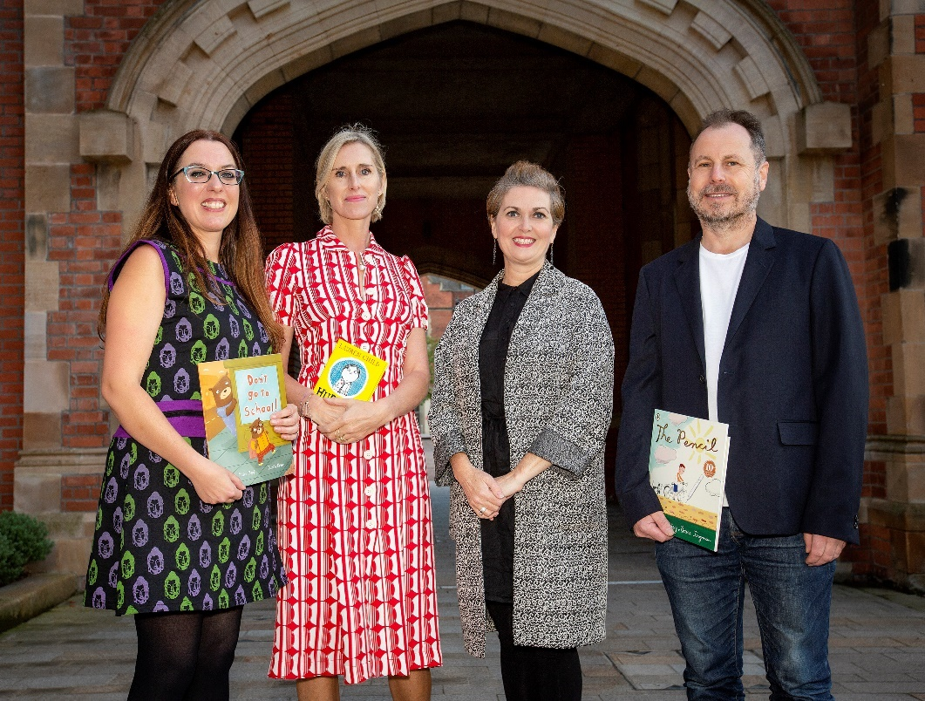
Myra Zepf, Lauren Child, Mare-Louise Muir and Bruce Ingman at Queens University Belfast for BookTrust NI event
Waterstones Children’s Laureate Lauren Child and guests Bruce Ingman and Myra Zepf discuss creativity
On Friday 21 September 2018 Lauren Child visited Queen's University Belfast for the first time as UK Children's Laureate for a special BookTrust Northern Ireland event. She was joined by Bruce Ingman and Myra Zepf for a lively discussion on creativity chaired by Mare-Louise Muir.
Speaking at the BookTrust NI event Lauren Child said: “We need to be able to fail in our lives. If we don’t take risks and fail, we will never make anything spectacular. I also think boredom and staring into space must be allowed. These spaces are the beginning of the imagination.”
BBC Radio Ulster presenter Mare-Louise Muir chaired an inspiring conversation on how to get children turning pages and the joy reading and creativity can bring to children’s lives. The authors and illustrators discussed the types of literature to share with children to help get them hooked on books and the importance of children’s writing and illustration as an artform.
Myra Zepf, Northern Ireland Children’s Writing Fellow on inspiring a love of reading: "When trying to inspire a love of reading, those children who don’t want to read can be the most interesting. I hope this event helped shine a spotlight on the challenges of cultivating creativity in children's lives - something we are arguably more in need of than ever. "
Children’s author and illustrator Bruce Ingman said: “Give a child some paint and a brush and see the pure joy it brings. They let us into their world, how exciting is that? I’ve learned so much from reading and drawing with kids.”
Guests at the event included Margaret Kelly, Director of Mencap NI, children’s illustrator Paul Howard, children’s author Pauline Burgess and Damian Smyth Head of Literature ACNI. The event took place at Queen’s University Belfast and was hosted by BookTrust NI who is supported through the Arts Council of Northern Ireland's National Lottery funds.
Liz Canning, Head of BookTrust Northern Ireland, said: “We are delighted Lauren Child made a special visit to Northern Ireland as The Waterstones Children’s Laureate. We hope this BookTrust hosted event helped inspire families and practitioners in Belfast to get reading and get creative!”
Damian Smyth, Head of Literature and Drama at the Arts Council of Northern Ireland: “Working closely with Booktrust in Northern Ireland means that the Arts Council can help with events such as this one – a unique opportunity to experience Lauren Child, the Waterstone’s UK Children’s Laureate, in conversation with Bruce Ingman and Myra Zepf about the importance of the artform of children’s writing and illustration. It’s a message we are delighted to endorse for all children and young people in the company of such excellent practitioners.”
ENDS
Press contact: Bethan Phillips, Press Officer BookTrust, bethan.phillips@booktrust.org.uk 020 7801 8848
BookTrust is the UK’s largest children’s reading charity. We work to inspire a love of reading in children because we know that reading can transform lives. Each year we reach 3.4 million children across the UK with books, resources and support to help develop a love of reading, because we know that reading can transform lives. Our books are delivered via health, library, schools and early year’s practitioners, and are supported with guidance, advice and resources to encourage the reading habit. Reading for pleasure has a dramatic impact on educational outcomes, well-being and social mobility, and is also a huge pleasure in itself. We are committed to starting children on their reading journey and supporting them throughout. www.booktrust.org.uk
About the Waterstones Children’s Laureate
The idea for the Children’s Laureate originated from a conversation between (the then) Poet Laureate Ted Hughes and children’s writer Michael Morpurgo. The role of Waterstones Children's Laureate, which has a bursary of £15,000, is awarded once every two years to an eminent writer or illustrator of children's books to celebrate outstanding achievement in their field. The appointment of a Waterstones Children's Laureate acknowledges the importance of exceptional children's authors in creating the readers of tomorrow. The role of Laureate covers the whole of the UK and is administered by BookTrust, the children’s reading charity, and sponsored by Waterstones. It would be appreciated if you could ensure your editorial is factually accurate by referring to the role in its full title, Waterstones Children’s Laureate, at least once. For more information please visit www.childrenslaureate.org.uk.

