BookTrust announces winners of Me, Myself and I competition
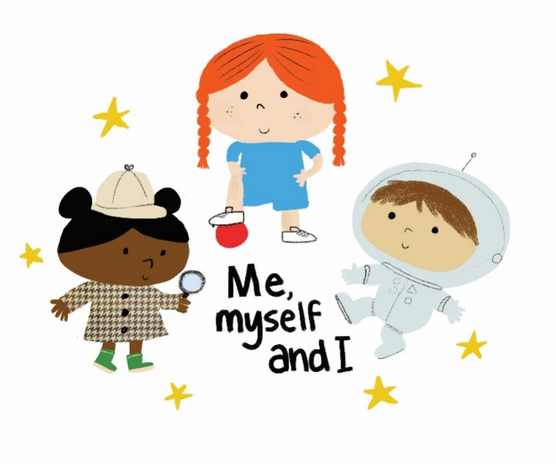

Nadia Shireen, BookTrust and Penguin Random House team up to print winners’ stories

Monday 9th July- Five budding authors and illustrators Nancy Biddlecombe, Charlie Parry, Jinyao Wang, Eissa Adebambi and Anya Mather have won Nadia Shireen’s Me, Myself and I competition.
BookTrust, the UK’s largest children’s reading charity, launched the competition with their current Writer in Residence Nadia Shireen in April 2018. Primary school children were asked to write a story of no more than 500 words putting themselves as the main character using their first name. The prize for the five lucky winners was getting their story printed by Penguin Random House.
BookTrust Writer in Residence Nadia Shireen said: “A huge hooray and thank you to every single young writer who entered the ‘Me, Myself and I’ competition. You’re amazing! I was completely overwhelmed by the number and quality of entries. Kids wrote in from every corner of the country with gorgeous, funny, inventive and - quite frankly - utterly *barmy* stories. It made me feel so proud and hopeful for our future, because we have a nation absolutely teeming with imaginative young writing talent. Well done, authors - you are absolutely crazy... but in the very best way. And please keep writing and drawing so we can all enjoy the brilliant worlds you have created.”

The winning stories My Little Brother Jamie, Leaping Beauty, The Battle vs Wizzard and ME! The Tree Monster and The Wrong Way, explored an eclectic mix of topics such as adventure, friendship and food!
Nadia set up the competition so that children could read a story about themselves because she believes it’s important that every young reader can see themselves represented in the books they read – regardless of gender, ethnicity or social class.
BookTrust CEO Diana Gerald said: “A huge congratulations to the five wonderful winners, your stories were brilliant and touched on some great topics such as adventure and friendship. We’ve loved working with Nadia on the ‘Me, Myself and I’ competition, helping children have more confidence to write themselves into stories. It’s such an important and excellent exercise as it helps to widen the appeal of reading, so that every child, whatever their background, sees reading as ‘for them’.”
ENDS
Press Contacts: Bethan Phillips, Press Officer, BookTrust, Bethan.phillips@booktrust.org.uk, 020 7801 8848
Notes to Editors
Winning Stories:
Leaping Beauty by Nancy Biddlecombe
My Little Brother Jamie by Charlie Parry
The Battle vs Wizzard and ME! by Jinyao Wang
The Tree Monster by Eissa Adebambi
The Wrong Way by Anya Mather
To read the winning stories and the runners up click here.
BookTrust is dedicated to getting children reading because we know that children who read are happier, healthier, more empathetic and more creative. Their early language development is supported and they also do better at school.
We are the UK’s largest children’s reading charity; each year we reach 3.4 million children across the UK with books, resources and support to help develop a love of reading, because we know that reading can transform lives.
We work with a variety of partners to get children excited about books, rhymes and stories, because if reading is fun, children will want to do it. Our books are delivered via health, library, schools and early years practitioners, and are supported with guidance, advice and resources to encourage the reading habit. booktrust.org.uk

The BookTrust Writer in Residence project has been running since March 2009 and has featured several authors and illustrators including Cressida Cowell, Sita Brahmachari, Patrick Ness, Polly Dunbar, Bali Rai, Matt Haig, Laura Dockrill, Chris Riddell, Sarah McIntyre, Philip Ardagh, Taran Matharu and Phil Earle. The residency encourages each writer or illustrator to explore topics that they are passionate about, with past residents exploring themes such as the power of stories, diversity in children’s literature and the importance of libraries.
Nadia Shireen enjoyed making homemade magazines and comics as a child, and during her time studying law at university and her subsequent career in journalism, she started to sketch again. After years of doodling in the sidelines, Nadia decided to pay more attention to drawing, and in 2007 was accepted onto an MA course in Children's Book Illustration at Anglia Ruskin. Her debut book Good Little Wolf received a mention in the Bologna Ragazzi Opera Prima Award, and went on to win the UKLA Book Award. Nadia’s subsequent books have since been shortlisted for the Roald Dahl Funny Prize, The Sainsbury’s Book Award and the Waterstones Children's Book Prize.

Nadia now writes and draws full time. In 2017 she partnered with Book Trust to promote their Time To Read campaign, and 700,000 copies of The Bumblebear were distributed to schoolchildren across the UK. She also contributed to the Great Get Together initiative, in memory of MP Jo Cox. In addition, Nadia is a Patron of the Ministry of Stories, and also supports the Penguin’s Write Now initiative for discovering under-represented voices.

In her spare time, Nadia enjoys obsessing over music, cooking curry, hanging out with her unfriendly cats, going for long walks and getting lost in sheep fields. She lives in London but dreams of living in a castle by the sea with a small army of trained wolves.

