Aneirin Karadog visits school children in Ceredigion
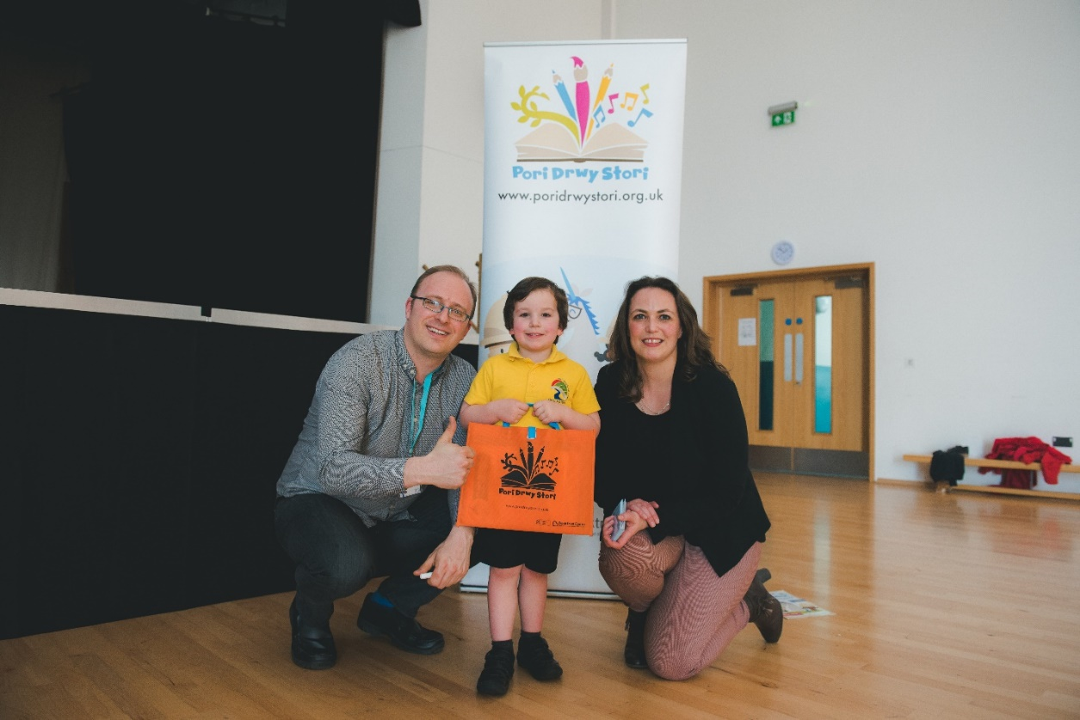
Aneirin Karadog with Cian Carmelo from Bro Teifi School and Rachel Lloyd from BookTrust (Photo credit: Betsan Haf Evans)

23 March 2018 – On Monday and Tuesday, poet Aneirin Karadog paid a visit to reception children in Ceredigion to celebrate reading, rhymes and stories.
The event, organised by BookTrust Cymru, the Welsh arm of the UK’s largest children’s reading charity was set up to encourage children to enjoy reading and share stories together from an early age. The events were supported by the Ceredigion Foundation Phase team.
200 reception children from seven local schools were involved in the workshops across two days. The sessions, delivered in Welsh by Aneirin, were based on the Boomerang Bags, part of BookTrust’s Pori Drwy Stori programme. The bags containing English and Welsh language books and fun activity magazines were given to every primary school in Wales in January. The bilingual book, Pip y Pengwin Bach (Rily Publications) was translated into Welsh by the former Bardd Plant Cymru. Pip the Little Penguin is a warm and funny rhyming story combined with the very best Alphaprint characters to make it a joy to share with young children.
Aneirin said: “The Pori Drwy Stori Scheme is really valuable, not only in terms of introducing the youngest children in Welsh schools to books and developing a love of reading, but also as this is an opportunity to stimulate the children’s imagination and foster creativity as we saw in our lively and successful series of workshops in some of Ceredigion’s schools lately.”
Pori Drwy Stori is a national programme for Reception-aged children in Wales, which is brought to schools by BookTrust Cymru. It is funded by the Welsh Government to support literacy, numeracy and family engagement in learning. Termly resources are delivered directly to schools, completely free of charge, for every 4-5 year-old child in Wales to enjoy using in the classroom and at home. The high quality, colourful resources include wonderful picture books in Welsh and English, fun numeracy games, and a special ‘Rhyme Challenge’ for children to enjoy.
Helen Wales, BookTrust’s Head of Country for Wales said: “It’s such a joy to see the children so excited about the Boomerang Book Bag books and to watch the story of Pip come to life. Learning to read is so important – but taking time to have fun with books and simply enjoy sharing stories is vital for every child. We want children and families to really enjoy sharing all the Pori Drwy Stori resources and to have fun reading, playing and learning together.”
In each interactive session Aneirin read stories, poems and rhymes, helped the children with crafts, using papers shapes to make their own penguins and everyday objects to make animal collages that were inspired by the illustrations in the book. Children were presented with certificates in a special ceremony to congratulate them for their new rhyme and listening skills.
Sioned Lloyd, a Reception Teacher who attended the event said: “The children from Bro Teifi School really enjoyed the session. They loved rhyming with Aneirin along with gluing and craft activities associated with shapes, the afternoon was fun and was very successful.”
Bethan Jones, Senior Foundation Phase Literacy Advisor said: “It’s an honour to welcome the chaired bard Aneirin Karadog to work with Ceredigion schools and to promote the Pori Drwy Stori programme. This is a special opportunity to stimulate and inspire Foundation Phase children to develop their Welsh language in a fun and creative way.”

[Ends]
Press Contacts: Sinéad Gosai, Press Officer, BookTrust, sinead.gosai@booktrust.org.uk, +44 (0)20 7801 8849
Notes to Editors
The Schools involved in the workshops are:
- Ysgol Aberteifi / Aberteifi School
- Ysgol Aberporth / Aberporth School
- Ysgol Penparc / Penparc School
- Ysgol Bro Pedr / Bro Pedr School
- Ysgol y Dderi / Y Dderi School
- Ysgol Bro Teifi / Bro Teifi School
- Ysgol T Llew Jones / T Llew Jones School

BookTrust is the UK’s largest children’s reading charity. BookTrust Cymru is the organisation’s office in Wales. We work to inspire a love of reading in children because we know that reading can transform lives. Each year we reach 3.4 million children across the UK with books, resources and support to help develop a love of reading, because we know that reading can transform lives. Every parent receives a BookTrust book in the baby’s first year. Our books are delivered via health, library, schools and early year’s practitioners, and are supported with guidance, advice and resources to encourage the reading habit. Reading for pleasure has a dramatic impact on educational outcomes, well-being and social mobility, and is also a huge pleasure in itself. We are committed to starting children on their reading journey and supporting them throughout. www.booktrust.org.uk/cymru
Pori Drwy Stori is the national programme for every child in Reception in Wales. It is designed, developed and delivered by BookTrust Cymru and funded by the Welsh Government to support family engagement in literacy and numeracy. www.poridrwystori.org.uk
Aneirin Karadog is a poet, broadcaster, performer and linguist. He won the chair at the National Eisteddfod in Monmuthshire in 2016. He has been a presenter on 'Heno' on S4C. Aneirin was the Children's Poet of Wales. He was a rapper and a member of the bands 'Genod Droog' and 'Diwygiad'. He was brought up in Ponytypridd but now lives in Pontyberem in the Gwendraeth Valley with his wife Laura and their children Sisial and Erwan. His father is Welsh and his mother comes from Brittany and Aneirin speaks Breton.

