Alex T. Smith visits children in Belfast to help inspire a love of reading

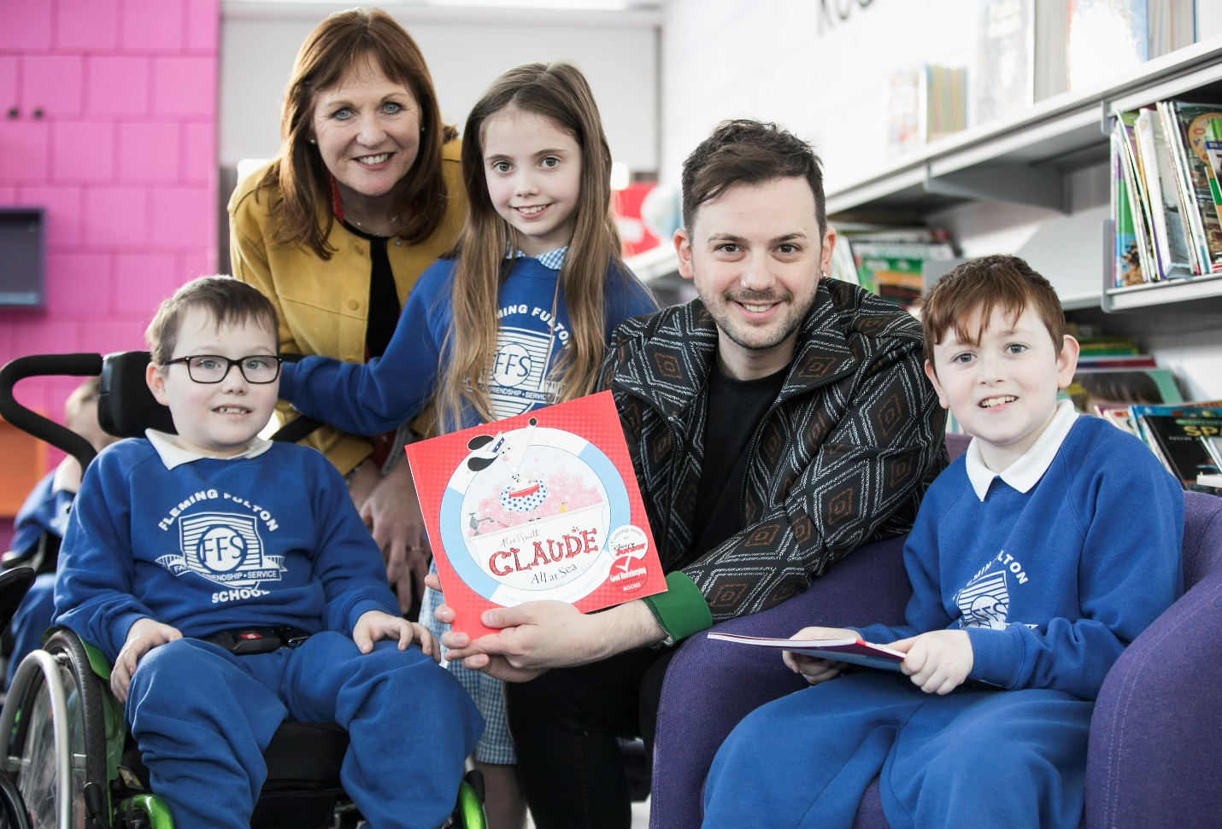Alex T. Smith with BookTrust’s Liz Canning and pupils from Fleming Fulton School in South Belfast

27th April 2018 - Author and illustrator Alex T. Smith paid a visit to schools in Belfast this week. The creator of the adorably funny Claude series of books, spent time at four local primary schools on 26th and 27th April encouraging children to enjoy reading and sharing stories.
BookTrust, the UK’s largest children’s reading charity exists to get kids reading. As part of the BookTrust NI Author Tour, authors and illustrator visit school children throughout the year helping them to develop a lifelong love of reading. Visits can include a book reading, interactive story time, live drawing, arts and crafts and more. Authors also take the time to personally sign copies of the books given to the children.
During his visit Alex met with over 250 school children, starting at Fleming Fulton School in South Belfast, then on to St Therese of Lisieux Primary School in North Belfast, Castle Gardens Primary School in Newtownards and Dundonald Primary School in Dundonald, giving students at each school a one-hour presentation about writing and illustration and encouraging them to draw along with him throughout. Each pupil was given their own free, personally signed copy of Alex’s new book, Mr. Penguin, to take home and share with their families.
Discussing the event Alex said: “I had a wonderful time visiting schools in Northern Ireland with BookTrust. Claude is being made into a TV programme by a hugely talented Belfast company called Sixteen South, so I’ve been coming over to Northern Ireland regularly for quite a few years now, but this was the first time I was in schools talking and drawing along with the children. In my events I aim to show the kids (and adults) that everyone can draw, everyone can have ideas and write, and that creativity can also have a sense of humour! I introduced them to Claude, and my new character, Mr Penguin, which went down a treat. Thank you so much to BookTrust for organising it all”
Nichola Nickels, Literacy coordinator at Fleming Fulton said: “We were delighted to have had the chance to meet an author/ illustrator. This is an amazing opportunity for the pupils of Fleming Fulton. They have enjoyed reading the books and finding out about Alex T Smith beforehand and loved meeting him in person.”
Damian Smyth, Head of Literature and Drama, Arts Council of Northern Ireland, said: “Artist visits like this are a fantastic opportunity for children to meet a successful writer and hear a story brought to life in the author’s own voice. An event like this is not only great fun for young audiences but hugely valuable, inspiring the imagination, and perhaps even encouraging children to start thinking about developing their own stories. The Arts Council is pleased to support BookTrust NI in promoting the value of reading to young people across Northern Ireland.”
Liz Canning, Head of BookTrust Norther Ireland said: “We’re delighted Alex was able to spend time with local school children in Belfast, sharing his experiences and wisdom. Many of the children were inspired by his talk, they all loved the illustrations and were very engaged, which is exactly what we hope when organising these events. The visit was made possible thanks to funding from the Arts Council NI Heritage Lottery Fund. Alex was the last of our authors to visit Northern Ireland as part of our 2017/2018 funding but we hope to continue hosting many more events. He is most certainly a tough act to follow.”
[Ends]
Press Contacts: Sinéad Gosai, Press Officer, BookTrust, sinead.gosai@booktrust.org.uk, +44 (0)20 7801 8849
Notes to Editors
Alex T. Smith is the creator of the Claude series of books, which are currently being developed into an animated series for Disney Junior. Mr. Penguin is Indiana Jones meets Hercule Poirot in this new Alex T. Smith series with plenty of slapstick humour, mystery and adventure. Highly illustrated throughout with a striking black and orange design.
BookTrust is the UK’s largest children’s reading charity. We work to inspire a love of reading in children because we know that reading can transform lives. Each year we reach 3.4 million children across the UK with books, resources and support to help develop a love of reading, because we know that reading can transform lives. Our books are delivered via health, library, schools and early year’s practitioners, and are supported with guidance, advice and resources to encourage the reading habit. Reading for pleasure has a dramatic impact on educational outcomes, well-being and social mobility, and is also a huge pleasure in itself. We are committed to starting children on their reading journey and supporting them throughout. www.booktrust.org.uk
Arts Council of Northern Ireland is the lead funding and development agency for the Arts. Our funding enables artists and arts organisations to increase access to the arts across society and deliver great art that is within everyone’s reach. National Lottery-funded arts programmes are bringing communities closer together, tackling prejudice, racism, isolation and mental health and improving emotional wellbeing. www.artscouncil-ni.org (twitter) @ArtsCouncilNI (facebook) \ArtsCouncilNI
The Arts Council of Northern Ireland Lottery Fund distributes a share of the money raised by The National Lottery for good causes.
- Over £30m is raised for good causes every week
- More than 500,000 projects have been funded
- Over £36bn has been raised since the Lottery started

