EMBARGO: TUESDAY 19 SEPTEMBER 00:01
Welsh Parents too hooked on screen time to read with kids
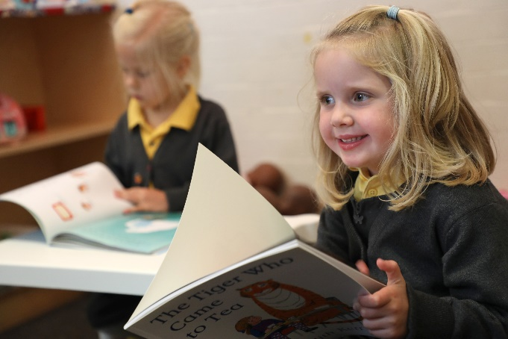
Alex Jones Pupils reading at Reay Primary School
- Welsh parents admit to scrolling on social and tuning into telly rather than reading with kids
- Tired mums and Dads skip stories to snooze instead
- Alex Jones, Dermot O’Leary and other famous faces support BookTrust’s National Time to Read challenge

19th September 2017 – A new survey released today by BookTrust, the UK’s largest children’s reading charity finds that Welsh mums and dads are spending over four times the amount of time (over 1.5 hours) engaging in screen time each day than they are reading with their children (19 mins).
The poll studied 2,000 parents of 4-11 year olds revealing that nearly half of parents in Wales confess to either frequently skipping pages when reading with children, finishing reading the story before the end or refusing to read a second story. Of those who admit to skipping pages, over half (53%) did so because they were too tired.
To help families find the time to read together this Autumn, BookTrust, alongside Welsh presenters Alex Jones and Lucy Owen and a host of other famous faces such as Dermot O’Leary and Mel Giedroyc are calling on parents and carers across the country to take part in the charity’s National Time to Read challenge (18-22 September) to free up ten minutes a day to share a story. Families can get involved on social media #TimetoRead or #AmseriDdarllen and share their swaps with the nation.
Supporting the campaign, TV personality Alex Jones said “Becoming a parent can be pretty daunting and comes with a never-ending to do list but reading with your little ones needn’t be a chore. Reading together is so much fun and helps us cement that bond. It doesn’t have to be regimented either, you can read anytime, anything and anywhere. I’m supporting BookTrust’s National Time to Read challenge by turning off my email notifications for an hour a day and spending some of that time with a quality book!”
Helen Wales Head of BookTrust Cymru said: “Regular reading helps imaginations to grow in the most fun and exciting way. Our survey reveals that over a third (37%) of children enjoy comics and magazines, proving that it’s not just books that get them turning pages, you really can read anything, anytime, anywhere. We hope families across the country will join us in finding ten minutes to read together – it really is all it takes to make a difference.’’
To find out more about BookTrust’s National Time to Read Challenge visit: www.booktrust.org.uk/TimetoRead
[Ends]
Press Contacts
Bethan Phillips: Bethan.phillips@booktrust.org.uk | +44 (0)20 7801 8848
Sinéad Gosai: Sinead.gosai@booktrust.org.uk | +44 (0)20 7801 8849
Notes to editors
The survey, commissioned by OnePoll on behalf of BookTrust polled 2,000 parents of 4-11 years olds in England, Northern Ireland and Wales whose child/children live at home 50% of the time.
Additional findings:
- In Wales reading is not perceived as a fun activity to engage in together throughout the day, with over half of Welsh parents (52%) saying they are more inclined to restrict reading to the bedtime routine.
- Nearly a fifth (17%) blame their lack of shared family reading on long working hours.
- When asked how they would choose to spend extra free time, Welsh parents were 3 times (48%) more likely to say they would play and talk with their child than they were too read with their child (16%)
- Over 3/4 (76%) of Welsh mums and dads acknowledge their child very much enjoys when they are read to by mum and dad, and 73% saying their child loves to share stories together.
About Time to Read - BookTrust’s annual Time to Read (Amser i Ddarllen) campaign runs from 18-22 Sept. Time to Read champions the value of shared reading, the importance of children’s reading for pleasure, and the impact of both on children’s life chances. Now in its second year, the
campaign provides schools and families with the advice and tools to make the most out of time spent reading together.
Celebrity supporters for Time to Read 2017 include: Dermot O’Leary, Mel Giedroyc, Lauren Laverne, Alex Jones, Sarah Beeny, Edith Bowman, Jeff Brazier, Helen Skelton, Lucy Owen and Johnny Ball.
Click here for celebrity and author quotes of support for Time to Read.
BookTrust is the UK’s largest children’s reading charity. BookTrust Cymru is the organisation’s office in Wales. We work to inspire a love of reading in children because we know that reading can transform lives. Each year we reach 3.4 million children across the UK with books, resources and support to help develop a love of reading, because we know that reading can transform lives. Every parent receives a BookTrust book in the baby’s first year. Our books are delivered via health, library, schools and early year’s practitioners, and are supported with guidance, advice and resources to encourage the reading habit. Reading for pleasure has a dramatic impact on educational outcomes, well-being and social mobility, and is also a huge pleasure in itself. We are committed to starting children on their reading journey and supporting them throughout. www.booktrust.org.uk/cymru

