EMBARGO: TUESDAY 19 SEPTEMBER 00:01
Northern Ireland Parents turn to digital devices in favour of reading with children
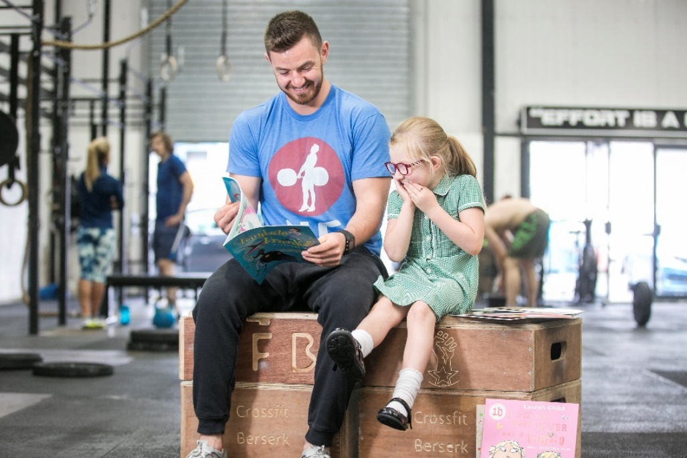
Eamon Kelly, owner of Crossfit Berserk in Belfast, reading with his daughter Eabha.

- Parents admit to choosing telly time and social scrolling over shared reading
- Dermot O’Leary, Alex Jones and other famous faces support BookTrust’s National Time to Read challenge

19th September 2017 – A new survey released today by BookTrust, the UK’s largest children’s reading charity finds that parents in Northern Ireland are spending nearly four times as much time (1 hour and 36 minutes) watching TV or on social media than they are reading to their children (21mins).
More than one in ten (14%) parents in Northern Ireland admit to having skipped entire pages or paragraphs during storytime with their children. Of those who have skipped pages or paragraphs, more than seven in ten (71%) said they have done this because they were worn-out.
The poll studied 2,000 parents of 4-11 year olds revealing that six out of ten mums and dads in Northern Ireland said if they had more free time, they would use it to play or talk to children, but only 18% said they would use more free time to read to their kids.
Of those parents that finished reading their child a story before the end, nearly three quarters (73%) say they did so because it was past their child’s bedtime. And over three quarters (79%) of parents chose the bedtime as their time to read with young ones.
To help families find the time to read together this Autumn, BookTrust, alongside presenters Dermot O’Leary, Alex Jones, Mel Giedroyc and a host of other famous faces are calling on parents and carers across the country to take part in the charity’s National Time to Read challenge (18-22 September) to free up ten minutes a day to share a story. Families can get involved on social media #TimetoRead and share their swaps with the nation.
Liz Canning, Head of BookTrust Northern Ireland said: “Reading is a special time to share a story and there are so many ways to make it fun. Stories don’t have to be exclusive to bedtime, especially if mums and dads are too tired. Books are portable and can be read at the breakfast table, on the school bus or even when dinner is in the oven. We know parents have little free time, so we’re encouraging them to find just ten minutes a day to share a story with their child.”
[Ends]
Press Contacts
Sinéad Gosai: Sinead.gosai@booktrust.org.uk | +44 (0)20 7801 8849
Bethan Phillips: Bethan.phillips@booktrust.org.uk | +44 (0)20 7801 8848
Notes to editors
The survey, commissioned by OnePoll on behalf of BookTrust polled 2,000 parents of 4-11 years olds in England, Northern Ireland and Wales whose child/children live at home 50% of the time.
Additional findings:
- 15% of parents in Northern Ireland confess to having finished reading their child a story before the end, with nearly three quarters (73%) of mums and dads admitting doing this because it was past their child’s bedtime.
- A quarter (25%) of respondents in Northern Ireland have refused their child a second story the most amount of times.
About Time to Read - BookTrust’s annual Time to Read campaign runs from 18-22 Sept. Time to Read champions the value of shared reading, the importance of children’s reading for pleasure, and the impact of both on children’s life chances. Now in its second year, the
campaign provides schools and families with the advice and tools to make the most out of time spent reading together.
Celebrity supporters for Time to Read 2017 include: Dermot O’Leary, Mel Giedroyc, Lauren Laverne, Alex Jones, Sarah Beeny, Edith Bowman, Jeff Brazier, Helen Skelton, Lucy Owen and Johnny Ball.
Click here for celebrity and author quotes of support for Time to Read.
BookTrust is the UK’s largest children’s reading charity. We work to inspire a love of reading in children because we know that reading can transform lives. Each year we reach 3.4 million children across the UK with books, resources and support to help develop a love of reading, because we know that reading can transform lives. Our books are delivered via health, library, schools and early year’s practitioners, and are supported with guidance, advice and resources to encourage the reading habit. Reading for pleasure has a dramatic impact on educational outcomes, well-being and social mobility, and is also a huge pleasure in itself. We are committed to starting children on their reading journey and supporting them throughout. www.booktrust.org.uk

