EMBARGO: TUESDAY 19 SEPTEMBER 00:01
Parents side-line storytime for social media
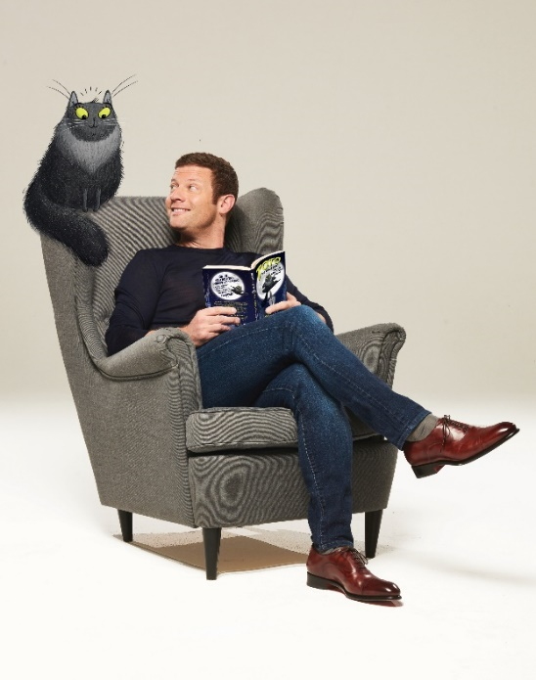
Dermot O’Leary Reay Primary School pupils with their Time to Read packs
- UK parents admit to scrolling on social and tuning into telly rather than reading with kids
- Tired mums and Dads skip stories to snooze instead
- Dermot O’Leary, Alex Jones and other famous faces support BookTrust’s National Time to Read challenge

19th September 2017 – A new survey released today by BookTrust, the UK’s largest children’s reading charity finds that UK mums and dads are spending nearly four times the amount of time (over 1.5 hours) engaging in screen time each day than they are reading with their children (25 mins)
The poll studied 2,000 parents of 4-11 year olds revealing that half of parents confess to either frequently skipping pages when reading with children, finishing reading the story before the end or refusing to read a second story. Of those who admit to skipping pages, half (49%) did so because they were too tired.
To help families find the time to read together this Autumn, BookTrust, alongside presenters Dermot O’Leary, Alex Jones, Mel Giedroyc and a host of other famous faces are calling on parents and carers across the country to take part in the charity’s National Time to Read challenge (18-22 September) to free up ten minutes a day to share a story. Families can get involved on social media #TimetoRead and share their swaps with the nation.
Supporting the campaign, TV personality Dermot O’Leary said ‘’Those moments when my niece and I share a book, letting our imaginations run wild, are pure bliss. Although it can be a struggle to find those magical moments, it is mega important that we all find the time to read with the children in our lives, helping them unlock the joys of reading. I totally support BookTrust’s National Time to Read challenge and will be swapping social media for storytime.’’
As part of its annual Time to Read campaign, BookTrust is delivering over 700,000 copies of Nadia Shireen’s picture book The Bumblebear to every reception age child in England.
BookTrust CEO Diana Gerald said: “Regular reading helps imaginations to grow in the most fun and exciting way. Our survey shows reveals 43% of children enjoy comics and magazines, proving that it’s not just books that get them turning pages, you really can read anything, anytime, anywhere. We hope families across the country will join us in finding ten minutes to read together - it really is all it takes to make a difference.’’
Click here to see Dermot’s challenge and find out why he thinks making Time to Read is so important. To find out more about BookTrust’s National Time to Read Challenge visit: www.booktrust.org.uk/TimetoRead
[Ends]
Press Contacts
Sinéad Gosai: Sinead.gosai@booktrust.org.uk | +44 (0)20 7801 8849
Bethan Phillips: Bethan.phillips@booktrust.org.uk | +44 (0)20 7801 8848
Notes to editors
The survey, commissioned by OnePoll on behalf of BookTrust polled 2,000 parents of 4-11 years olds in England, Northern Ireland and Wales whose child/children live at home 50% of the time.
Additional findings:
- Almost a fifth of parents (18%) blame their lack of shared family reading on long working hours.
- Reading is not perceived as a fun activity to engage in together throughout the day, with over half of parents (54%) saying they are more inclined to restrict reading to the bedtime routine.
- More than eight in ten (81%) parents acknowledge their child very much enjoys when they are read to by mum and dad, and nearly three quarters (73%) saying their child loves to share stories together.
- When asked how they would choose to spend extra free time, 44% of parents say they would like to spend more talking and playing with their children compared to only 16% who say they would use this time to read together.
Lauren Child, The Waterstones Children Laureate said: "Reading aloud with your child at any age is a wonderful way of connecting because you see what excites them and interests them, and it’s also a way of understanding what’s going inside their head. And it’s letting them know by example that books are a good thing, creating a habit of reading and a special bond. It’s also a lovely way of winding down at the end of a day for both parent and child."
About Time to Read - BookTrust’s annual Time to Read campaign runs from 18-22 Sept. Time to Read champions the value of shared reading, the importance of children’s reading for pleasure, and the impact of both on children’s life chances. Now in its second year, the
campaign provides schools and families with the advice and tools to make the most out of time spent reading together.
Celebrity supporters for Time to Read 2017 include: Dermot O’Leary, Mel Giedroyc, Lauren Laverne, Alex Jones, Sarah Beeny, Edith Bowman, Jeff Brazier, Helen Skelton, Lucy Owen and Johnny Ball.
Click here for celebrity and author quotes of support for Time to Read.
Every year for Time to Read BookTrust gifts books to every reception aged child in England. This year, we chose The Bumblebear (Penguin Random House), written by Nadia Shireen. A colourful and entertaining tale following Norman the bear's adventures at Bee School.
BookTrust is the UK’s largest children’s reading charity. We work to inspire a love of reading in children because we know that reading can transform lives. Each year we reach 3.4 million children across the UK with books, resources and support to help develop a love of reading. Every parent receives a BookTrust book in their baby’s first year. Our books are delivered via health, library, schools and early year’s practitioners, and are supported with guidance, advice and resources to encourage the reading habit. Reading for pleasure has a dramatic impact on educational outcomes, well-being and social mobility, and is also a huge pleasure in itself. We are committed to starting children on their reading journey and supporting them throughout. booktrust.org.uk
Toto the Ninja Cat and The Great Snake Escape
Join Toto for an action-packed animal escapade written by one of the UK’s best loved broadcasters, The X Factor and BBC Radio 2 presenter, Dermot O’Leary and featuring black and white illustrations throughout from Nick East.
For fans of The Aristocats, The Secret Life of Pets and 101 Dalmatians, Toto the Ninja Cat is purrfect for reading aloud or for children aged 7 – 9-years olds to curl up with and read alone.
With gentle themes of friendship, inclusivity and winning in the face of adversity, this is an endearing must-read for all animal-loving kids and is Dermot’s debut work for children, inspired by his own real life cats.
The book stars Toto the cat and her brother Silver, who live in a town house in London. Toto is almost totally blind, and learned to trust her senses from a ninja cat master back in Italy where they were born. By day, Toto and Silver are ordinary cats, but by night, they find themselves having all kinds of adventures.
One evening, news reaches Toto that a king cobra has escaped from London Zoo! Together with help from a very posh cat and two hungry tigers, Toto and Silver must investigate. Can they find the giant snake, before it’s too late?
Toto the Ninja Cat and The Great Snake Escape , by Dermot O'Leary (illustrated by Nick East) publishing 21st September, paperback, £6.99 from Hodder Children’s Books, aimed at 7 – 9-year olds. Also available as an unabridged audiobook narrated by Dermot O’Leary.
#TototheNinjaCat @radioleary

