EMBARGO: TUESDAY 19 SEPTEMBER 00:01
London parents cutting short story time for Shiraz

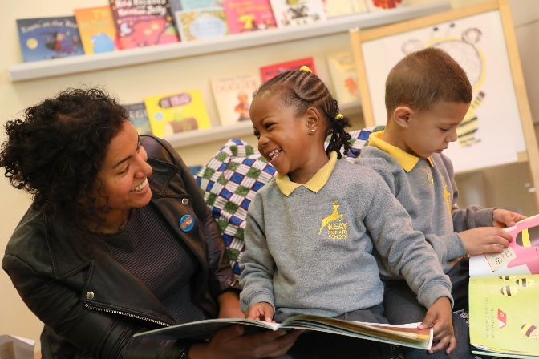
Author Nadia Shireen with Reay Primary School pupils Reay Primary School pupils with their Time to Read packs

- Exhausted London mums and dad shorten stories for a glass of wine

- London parents and carers admit to choosing social media over reading with kids

- London school kids personally receive free book by children's author Nadia Shireen for BookTrust's National Time to Read campaign

19th September- Polling released today by BookTrust, the UK's largest children's reading charity finds nearly a 1/4 (24%) of London parents confess to skipping pages, when reading to youngsters, and over a 1/3 (36%) admit finishing a story before the end. Of those who finished a story before the end, nearly 6 in 10 (58%) state they've done it to get children to bed and have a drink.

The survey studied 2,000 parents of 4-11 year olds revealing London mums and dads are spending twice the amount of time (1.5 hours) engaging in screen time each day than they are reading with their children (40 mins).

As part of its annual Time to Read campaign, BookTrust is delivering over 700,000 copies of Nadia Shireen's picture book The Bumblebear to every reception age child in England. On 11th September, Londoner Nadia handed out copies of her book to a crowd of giddy school starters at Reay Primary School, Lambeth. The children were also treated to a special story time and draw along session with Nadia.

On visiting the school Nadia Shireen said: “I am delighted The Bumblebear has been chosen as BookTrust’s Time to Read campaign book, it was loads of fun doing a story time session with the kids at Reay Primary School. It’s so important families make time to read together as it is a lovely opportunity to snuggle with a book, have a laugh and share some special time together. To help get your kids excited about reading, let them read what they want!”

To help families find the time to read this autumn, BookTrust, alongside presenters Dermot O' Leary, Alex Jones, Mel Geidroyc and a host of other faces are calling on parents and carers across the country to take part in the charity's National Time to Read challenge (18-22nd September) to free up ten minutes a day to share a story. Families can get involved on social media #TimeToRead and share their swaps with the nation.

BookTrust CEO Diana Gerald said: "Regular reading helps imaginations to grow in the most fun and exciting way. Our survey reveals 43% of London children enjoy comics and magazines, proving that it's not just books that get them turning pages, you really can read anything, anytime, anywhere. We hope families in London will join us in finding ten minutes to read together- it really is all it takes to make a difference."

Click here to see filming of Reay Primary School children receiving their Time to Read pack

Click here to see Dermot’s challenge and find out why he thinks making Time to Read is so important. To find out more about BookTrust’s National Time to Read Challenge visit: www.booktrust.org.uk/TimetoRead

[Ends]

Press Contacts

Bethan Phillips: Bethan.phillips@booktrust.org.uk | +44 (0)20 7801 8848
Sinéad Gosai: Sinead.gosai@booktrust.org.uk | +44 (0)20 7801 8849

Notes to editors
The survey, commissioned by OnePoll on behalf of BookTrust polled 2,000 parents of 4-11 years olds in England, Northern Ireland and Wales whose child/children live at home 50% of the time.

Additional findings:

- Long working hours are the top barrier London parents and carers face when reading with their child, with nearly a 1/3 (32%) admitting it prevents shared reading.

- London mums and dads most likely, compared to other regions, to read with their kids outside of an evening with over a 1/3 (36%) reading with their kids in the morning, to and from school or at tea time.

- London kids have a more varied reading library than the rest of the regions with 1 in 10 reading newspapers (10%) cereal boxes (14%) and plays (14%) and 16% reading anime and manga.

- When asked how they would choose to spend extra time, 34% of London parents say they would like to spend more time gardening, compared to 8.5% who would spend more time reading with their kids

- Over 3/4 (78%) of London mums and dads acknowledge their child very much enjoys being read to by mum and dad, and 67% saying their child loves shared stories together.

About Time to Read - BookTrust’s annual Time to Read campaign runs from 18-22 Sept. Time to Read champions the value of shared reading, the importance of children’s reading for pleasure, and the impact of both on children’s life chances. Now in its second year, the
campaign provides schools and families with the advice and tools to make the most out of time spent reading together.

Celebrity supporters for Time to Read 2017 include: Dermot O’Leary, Mel Giedroyc, Lauren Laverne, Alex Jones, Sarah Beeny, Edith Bowman, Jeff Brazier, Helen Skelton, Lucy Owen and Johnny Ball.

Click here for celebrity and author quotes of support for Time to Read.

Every year for Time to Read BookTrust gifts books to every reception aged child in England. This year, we chose The Bumblebear (Penguin Random House), written by Nadia Shireen. A colourful and entertaining tale following Norman the bear's adventures at Bee School.

BookTrust is the UK’s largest children’s reading charity. We work to inspire a love of reading in children because we know that reading can transform lives. Each year we reach 3.4 million children across the UK with books, resources and support to help develop a love of reading. Every parent receives a BookTrust book in their baby’s first year. Our books are delivered via health, library, schools and early year’s practitioners, and are supported with guidance, advice and resources to encourage the reading habit. Reading for pleasure has a dramatic impact on educational outcomes, well-being and social mobility, and is also a huge pleasure in itself. We are committed to starting children on their reading journey and supporting them throughout. booktrust.org.uk

