BookTrust Celebrates Father’s Day with top picture books about Dads

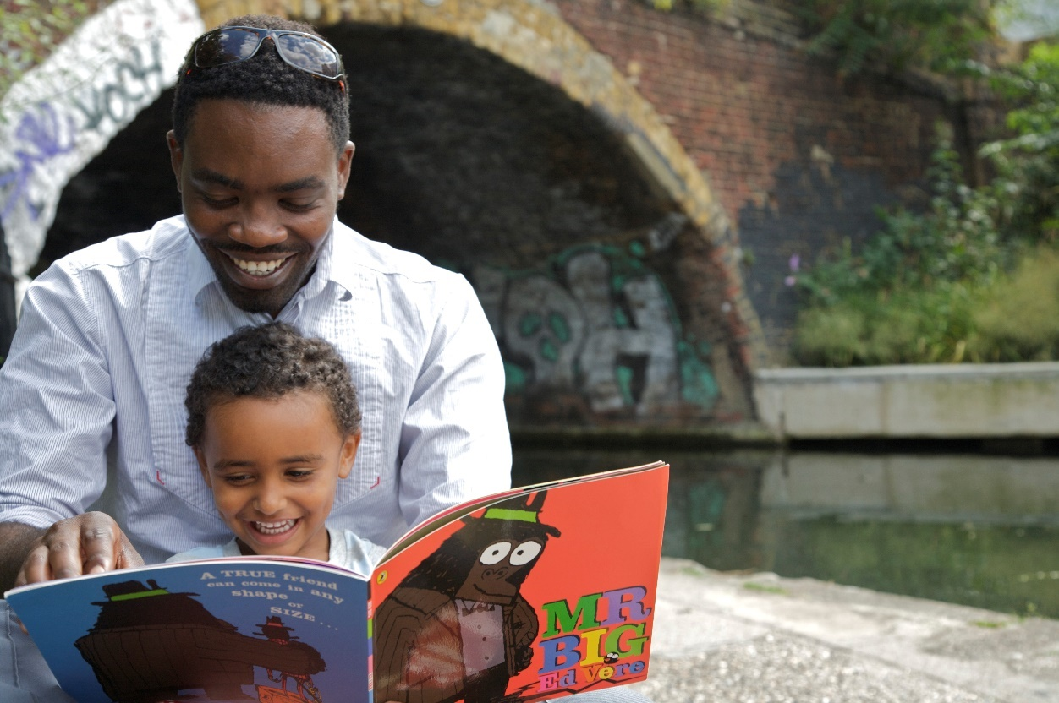

14 June 2017 - Father’s Day is fast approaching and to celebrate the occasion, BookTrust, the UK’s largest children’s reading charity has put together some suggestions on the top dad themed books for anyone who wants to give the hero in their life something more than slippers this year
We know from research that reading for pleasure not only increases literacy skills and more but it helps to build a strong and loving relationship between you and your child. This Father's Day is the perfect time for you and your little (or not so little one) to snuggle up with a good book and share a story together.
- Set aside some time - Find somewhere quiet without any distractions - turn off the TV/radio/computer.
- Ask your child to choose a book - Sharing books they have chosen shows you care what they think and that their opinion matters. This means they are more likely to engage with the book.
- Sit close together - Encourage your child to hold the book themselves and/or turn the pages.
- Point to the pictures - If there are illustrations, relate them to something your child knows. Ask them to describe the characters or situation or what will happen next. Encourage them to tell you the story by looking at the pictures.
- Encourage your child to talk about the book - Talking about the characters and their dilemmas helps children understand relationships and is an excellent way for you to get to know each other or discuss difficult issues. Give your child plenty of time to respond. Ask them what will happen next, how a character might be feeling, or how the book makes them feel.
- And lastly, above all - make it fun! - It doesn't matter how you read with a child, as long as you both enjoy the time together. Don't be afraid to use funny voices: children love this!
CEO of BookTrust, Diana Gerald said “Reading with children not only keeps them entertained but a love of reading also brings with it enormous benefits as well as helping to increase the bond between parent and child so this Father's Day we want all father figures to share a story with their children.”
Tom Fletcher, Singer/Guitarist in McFly, children’s author and Dad to Buddy and Buzz said "Since having children I've definitely realised how important it is to entertain the parent reading the book as well as the kids. Buzz likes slightly different books to Buddy so I turn the lights off and we read in bed with a torch. It makes it really fun."
Top books to read together this Father’s Day on Sunday 18th June *See notes to editor for the full list or Click Here

Dustbin Dad by Peter Bently (Simon & Schuster)
Dad eats everything - from half-eaten pies and unwanted sandwiches to soggy old bits of tomato and manky spaghetti. Then one day he bites off more than he can chew...
Amazing Daddy by Rachel Bright (Orchard Books, Hachette)
Unabashedly going straight for the heartstrings, this picture book looks at the father-child love between two every-day, house-dwelling pandas. It's full of lovely, funny details that never tips into schmaltziness.
My Dad is Brilliant by Nick Butterworth (Walker Books)
This dad does everything well: from running like a cheetah to singing like a pop star. Quite simply, he's brilliant. This board book version of a much-loved story brims over with an adorable, young enthusiasm for dads everywhere.

Superdad’s Day Off by Phil Earle (Little Gems)
Stanley is an ordinary boy from an ordinary family, with one notable exception: his father is a superhero. With lively, colourful illustrations, short chapters and clear, well-spaced text, this very funny tale is ideal for reluctant readers.

Just Like Daddy by Lucy Freegard (Pavilion)
A baby raccoon dreams of growing up to be just like Daddy in this cute, heart-warming book that's perfect for fathers to share with their little ones.
[Ends]
Press Contacts: Sinéad Gosai, Press Officer, BookTrust, sinead.gosai@booktrust.org.uk, +44 (0)20 7801 8849
Notes to editors
The Full Father’s Day booklist – June 2017:

Dustbin Dad by Peter Bently (Simon & Schuster)
Dad eats everything - from half-eaten pies and unwanted sandwiches to soggy old bits of tomato and manky spaghetti. Then one day he bites off more than he can chew...
Amazing Daddy by Rachel Bright (Orchard Books, Hachette)
Unabashedly going straight for the heartstrings, this picture book looks at the father-child love between two every-day, house-dwelling pandas. It's full of lovely, funny details that never tips into schmaltziness.
My Dad is Brilliant by Nick Butterworth (Walker Books)
This dad does everything well: from running like a cheetah to singing like a pop star. Quite simply, he's brilliant. This board book version of a much-loved story brims over with an adorable, young enthusiasm for dads everywhere.

Superdad’s Day Off by Phil Earle (Little Gems)
Stanley is an ordinary boy from an ordinary family, with one notable exception: his father is a superhero. With lively, colourful illustrations, short chapters and clear, well-spaced text, this very funny tale is ideal for reluctant readers.

Just Like Daddy by Lucy Freegard (Pavilion)
A baby raccoon dreams of growing up to be just like Daddy in this cute, heart-warming book that's perfect for fathers to share with their little ones.

My Dad Thinks He's Funny by Katrina Germein (Walker Books)
What do you do when your Dad has a terrible sense of humour? And he repeats the same jokes over and over again?

My Daddy is a Silly Monkey by Dianne Hofmeyr and Carol Thompson (Otter-Barry Books)
A little girl imagines her busy Daddy as all sorts of animals during their packed day in a playful, warm story about a single father and his daughter.
Alfie and Dad by Shirley Hughes (Bodley Head)
This collection of three classic Alfie stories is a charming reminder of just how perfectly Shirley Hughes understands little ones.
Just Like My Dad by David Melling (Hodder Children's Books)
A little lion cub loves and respects his dad. He wants to grow up to be just like him, with sharp teeth, long nails and a swishy tail.
My Dad Used To Be So Cool by Keith Negley (Flying Eye Books)
Unfolding like a detective story, the son in this story sets out to discover if his dad was ever cooler than he seems right now. After all - the evidence is stacked against him!
Daddy Do My Hair: Beth’s Twists by Tola Okogwu (Florence Elizabeth Publishing)
Softly rhyming text and glowing, illustrations in this calm, gentle book celebrate an apparently insignificant domestic ritual, which means everything to this father and daughter as they make time for each other.

Goodnight Spaceman by Michelle Robinson (Puffin)
Opening with a special letter from the first British ESA astronaut Tim Peake, this rhyming picture book will inspire any child who gazes at the night sky, longing to explore space. Informative, exciting and beautifully illustrated.

BookTrust is the UK’s largest children’s reading charity. We work to inspire a love of reading in children because we know that reading can transform lives. Each year we reach 2.5 million children across the UK with books, resources and support to help develop a love of reading, because we know that reading can transform lives. Every parent receives a BookTrust book in their baby’s first year. Our books are delivered via health, library, schools and early year’s practitioners, and are supported with guidance, advice and resources to encourage the reading habit. Reading for pleasure has a dramatic impact on educational outcomes, well-being and social mobility, and is also a huge pleasure in itself. We are committed to starting children on their reading journey and supporting them throughout. www.booktrust.org.uk

