EMBARGOED: 07:00 AM Thursday 19th October 2017

Children’s books should be taken seriously argues new Waterstones’ Children’s Laureate, Lauren Child

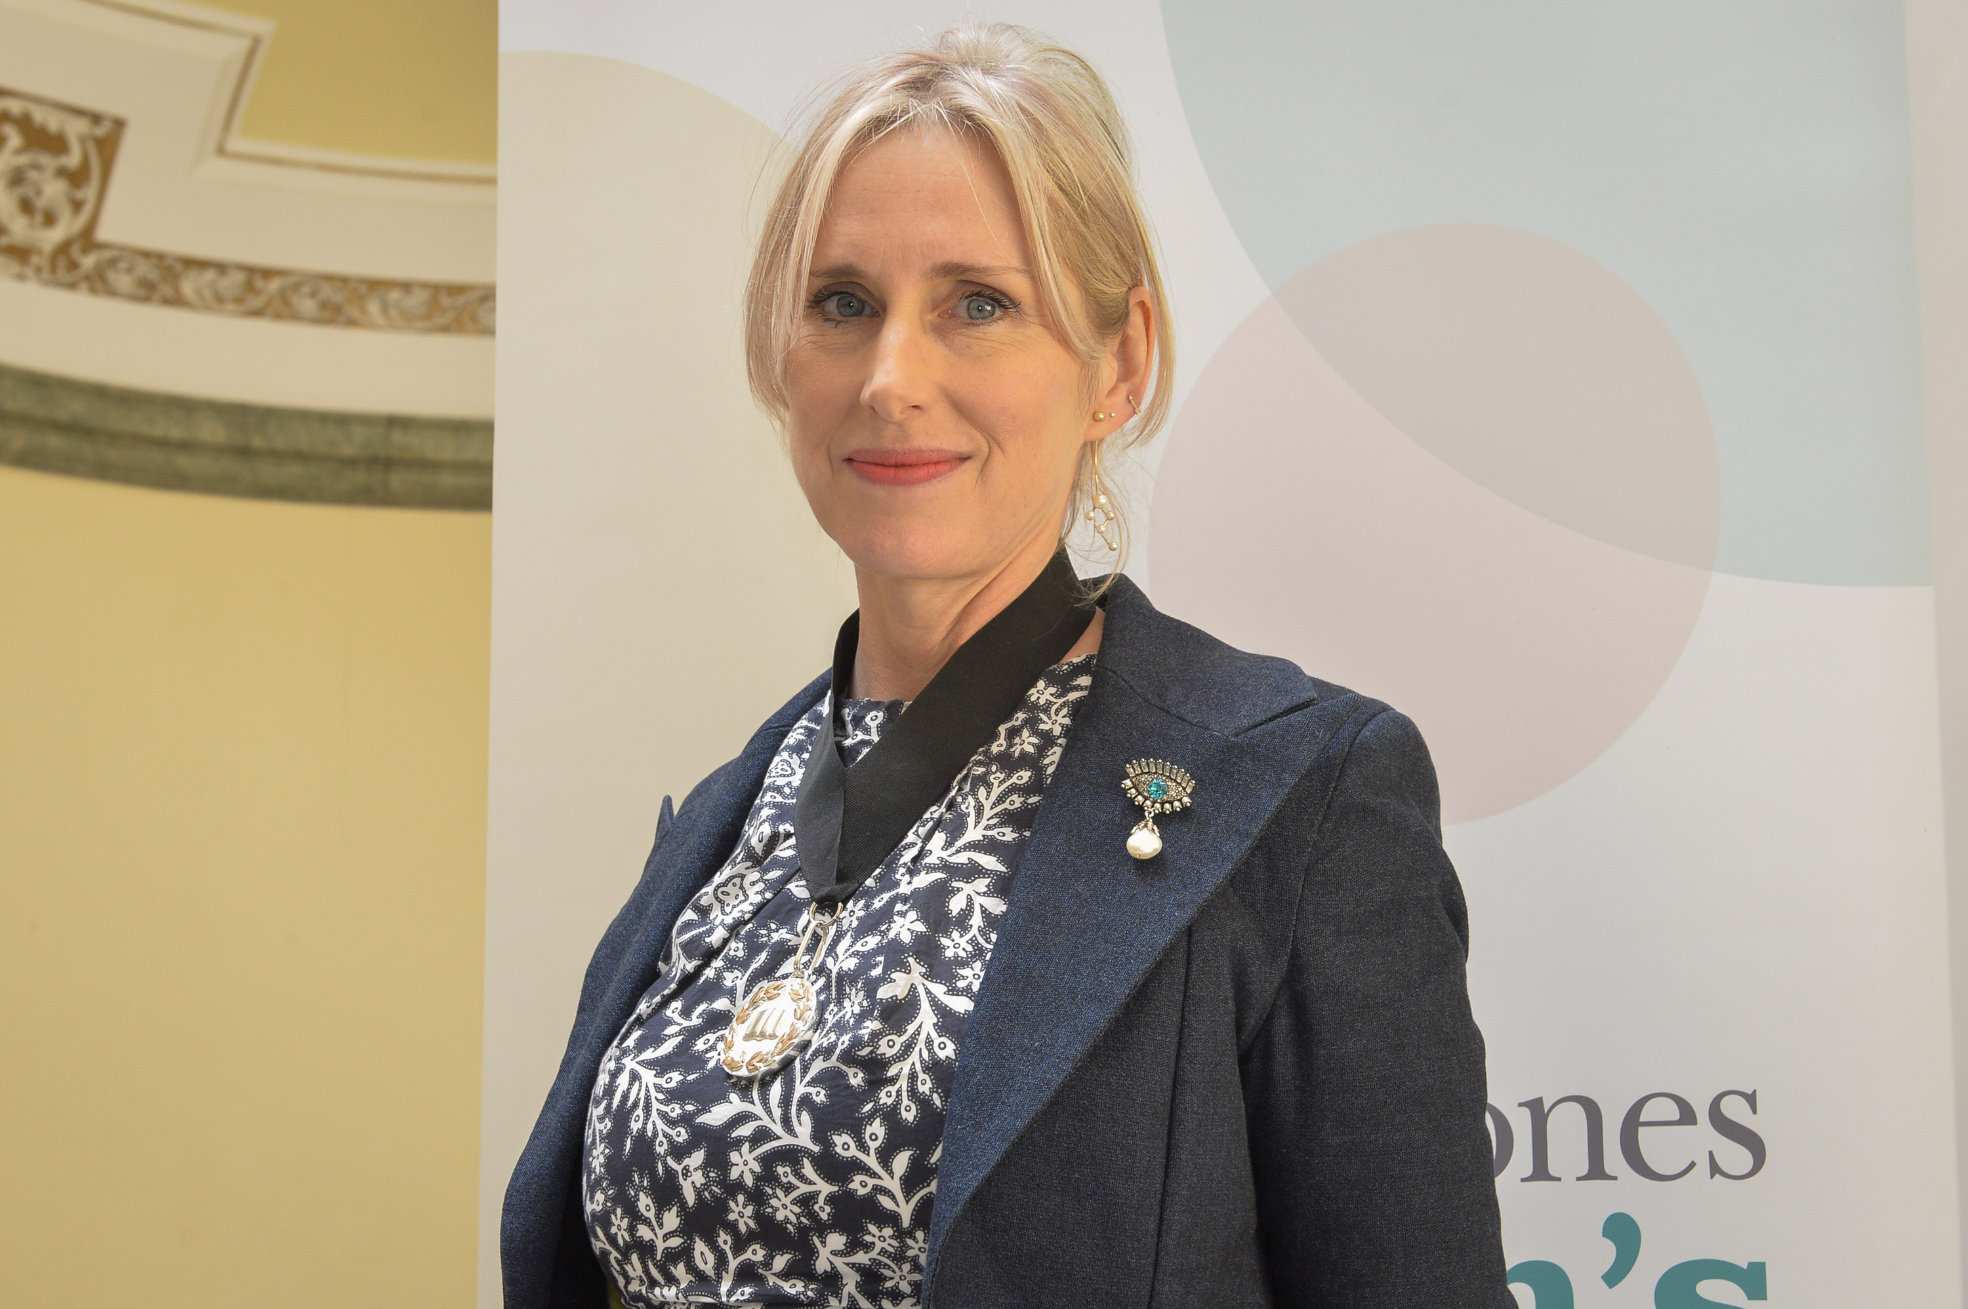

Lauren Child, best -selling author of Charlie and Lola and Ruby Redfort, and the current Waterstone’s Children’s Laureate will today tell an audience at BookTrust’s second Annual Lecture at RIBA, London that writing children’s books is an art form that should be valued and taken seriously.
“Illustration doesn’t just decorate the text, it takes it so much further- it conveys a darkness- or a lightness that is not there in the words. Children’s illustration is seen as ‘nice’ but actually it communicates something of ourselves.”
She will argue that because children are often not taken seriously, then children’s books aren’t considered important either. But Child says, “Children’s emotions are so powerful. They are arguably the hardest audience out. If they don’t like something they are not going to stick around politely.” Her lecture will illustrate how children’s books can be incredibly sophisticated, powerful and life-changing.
Child feels that the work of authors and illustrators should be valued and organisations like BookTrust, The UK’s largest Children’s Reading Charity and libraries should be supported so that every child can have access to quality books from an early age in an affordable way.
The title of her lecture given on Thursday 19th October at RIBA in London to an audience of her peers and the publishing industry will be ‘What do you think about when you think about nothing.’
The worldwide best-selling author is a strong advocate of creativity being at the heart of everything we do, both as children and adults. She argues that children should be allowed to dream and to let their creative minds run free in order to explore the true benefits of creativity for emotional support and connectivity to the wider world. Creativity, as she sees it, is a life changer. It is increasingly accepted that a lack of creative outlet has a negative impact on our mental health – but while children learn through playing, we don’t let ourselves have this space as adults. Idle time to experiment and enjoy – to do things for the sheer pleasure of doing them has been squeezed out of our lives and, Child will argue, we need it back.
Child is also calling for the publishing industry to take a serious look at diversity on a deeper level. She acknowledges that lip service has been paid to this issue but she is challenging the industry to make real changes led by publishers and authors.
BookTrust held its inaugural Annual Lecture in 2016 which was delivered by Michael Morpurgo, the third Children’s Laureate from 2003-2005. The BookTrust Annual Lecture is designed to give a platform for debate around children’s reading for leading industry figures.
BookTrust CEO, Diana Gerald says;
“We are delighted to host the second BookTrust Annual Lecture and honoured to welcome Lauren Child to the stage. It is vital that views and issues within the children’s reading space continue to be debated and discussed and this is very positive platform in which to do that. At BookTrust we are all about getting children reading for pleasure. Children who enjoy reading are happier, healthier and more empathetic. They do better in life generally. Children need to be supported to find books that they love and BookTrust delivers books and guidance to over 3.4 million children each year in order to help this happen.”
ENDS
For more information please contact:
Bethan Phillips, Press Officer, BookTrust, 020 7801 8848, Bethan.phillips@booktrust.org.uk

Sinéad Gosai, Press Officer, BookTrust, 020 7801 8849, Sinead.gosai@booktrust.org.uk

Notes to Editors
Lauren Child
Lauren Child is a multi-award-winning, bestselling writer and artist and the current Waterstones Children’s Laureate.

Her first two books were published in 1999 – I Want a Pet and Clarice Bean, That’s Me, and she won the prestigious Kate Greenaway Medal in 2000 for I Will Not Ever Never Eat a Tomato, the first of her Charlie and Lola picture books. Child published her first Clarice Bean novel in 2002 – Utterly Me, Clarice Bean. The Clarice Bean series has sold over 6 million copies worldwide.

In October 2005, the BBC launched a 78-part animated series of Charlie and Lola. The series has won four BAFTAS and is aired in more than 34 countries.

In 2008 Child launched UNESCO’s ‘My Life is a Story’ Campaign for UNESCO’s Programme for the Education of Children in Need, and was named a UNESCO Artist for Peace in 2008. In 2010 she was awarded an MBE for Services to Literature.

Child is an international ambassador for the excellence of UK illustration: she’s been at the forefront of innovation for 15 years and has raised the profile of illustration as a sophisticated art form for all ages. She works with mixed media, pioneered text as an integral part of illustration and collaborates with artists across different fields. She is a trustee of the recently-formed House of Illustration.

Child is also a passionate advocate for visual literacy and the importance of quality picture books for children.

The latest Charlie and Lola book, A Dog with Nice Ears, was published in September 2017. Ruby Redfort #6 Blink and You Die, the final book in the series was published in October 2016.

BookTrust
BookTrust is the UK’s largest children’s reading charity. We want to get children reading because we know that reading can transform lives. Each year we reach 3.4 million children across the UK with books, resources and support to help develop a love of reading. Every parent receives a BookTrust book in their baby’s first year. Our books are delivered via health, library, schools and early year’s practitioners, and are supported with guidance, advice and resources to encourage the reading habit. Reading for pleasure has a dramatic impact on educational outcomes, well-being and social mobility, and is also a huge pleasure in itself. We are committed to starting children on their reading journey and supporting them throughout. booktrust.org.uk

