Celebrate BookTrust’s Children’s Book Week at home with bumper Great Books Guide
New guide is packed full of fun reading material, so you’re sure to find something for everyone

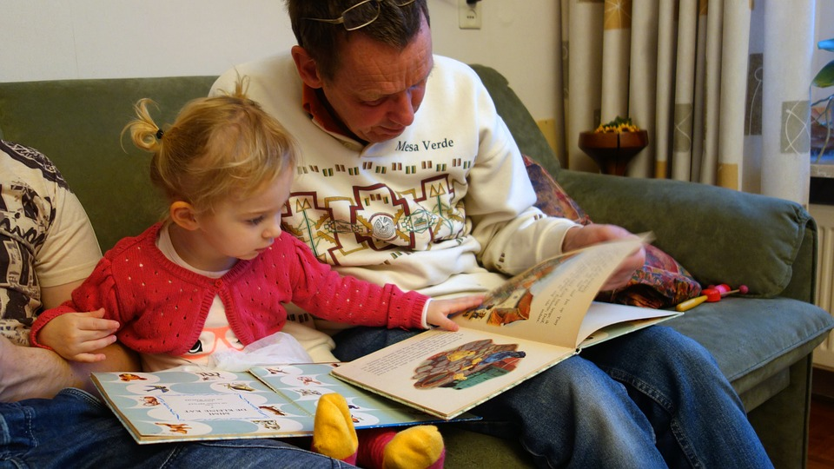

13 November 2017 - BookTrust, the UK’s largest children’s reading charity today unveils its 2017 Great Books Guide to celebrate Children’s Book Week. The guide highlights some of the brilliant books that have been published in the past year that will help families along their reading journey.

This year, for the very first time, BookTrust’s Great Books Guide includes book recommendations for 0-5s and 12 plus, so all children have access to and can find the fun in stories. The guide highlights 60 books that BookTrust thinks are great and that children will want to read – books that are funny, sad, informative, scary and silly (and everything in between).

Children who enjoy reading have better life chances. Reading enjoyment also helps to build confidence, wellbeing, development, attainment and social skills.

Diana Gerald, CEO of BookTrust said: “BookTrust’s aim with Children’s Book Week is simple – to help children love books and stories. We believe that the right book is always the book that a child actually wants to read, and we hope that within the pages of our guide you’ll find the ‘right’ book for lots of children in your school.”
Author and BookTrust’s writer in residence, Taran Matharu said: “Children's Book Week is hugely important, dedicating time to help children find the books they need to reignite their passion for reading.”
To help you celebrate Children’s Book Week this year, BookTrust has some handy tips and advice for families to have fun sharing stories.
Tips for families
- Read aloud to each other from a special book - whether an old favourite or new adventure.
- Choose books that suit your child's interests - whether they love comics, football, pets or dancing, there are hundreds of books that will capture their imagination.
- If they want to read the same thing over and over, that's fine - what matters is that they are enjoying the experience.
- Keep lots of books around - you can borrow from friends and family or the library, or buy from car boot sales, charity shops, bookshops or online.
- Fantastic books are often made into amazing adaptations - find out how your top title has been used, and then visit it as a musical or watch the film to see what you think!
- If you're stuck for ideas, ask a librarian or someone who works in a bookshop for advice. They love to talk about good books and will be happy to help.
[Ends]

Press Contacts: Sinéad Gosai | Sinead.gosai@booktrust.org.uk | +44 (0)20 7801 8849

Notes to editors

The books chosen for the Great Books Guide were picked by a panel of experts including bookshop owners, parent bloggers and librarians, as well as BookTrust’s own in house team. The books selected are a diverse range of titles that will get a wide variety of readers excited for reading for pleasure, with the idea that by using the guide parents will find great books for all children.

BookTrust is the UK’s largest children’s reading charity. We work to inspire a love of reading in children because we know that reading can transform lives. Each year we reach 3.4 million children across the UK with books, resources and support to help develop a love of reading. Every parent receives a BookTrust book in their baby’s first year. Our books are delivered via health, library, schools and early year’s practitioners, and are supported with guidance, advice and resources to encourage the reading habit. Reading for pleasure has a dramatic impact on educational outcomes, well-being and social mobility, and is also a huge pleasure in itself. We are committed to starting children on their reading journey and supporting them throughout. booktrust.org.uk

