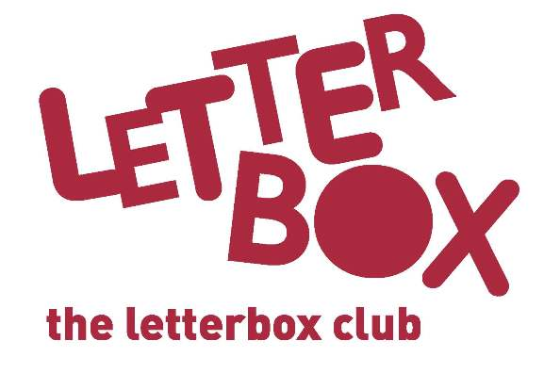
Carer/Parent name
Address 1
Address 2
Address 3
Postcode

Date

Welcome to the Letterbox Club!

Dear Carer/Parent,

[Insert local authority] is taking part in the Letterbox Club, a programme which aims to inspire a love of reading and engagement with numeracy in children aged 3-13. It’s run by a reading charity called BookTrust, in partnership with the University of Leicester.

We’re excited to let you know that your child has been enrolled for the programme, which means they receive a brightly coloured parcel, once each month for six months. Please note that your child will have received at least one of their parcels already, at their previous placement.

Letterbox Club parcels are for your child to own and keep, and contents include:

- A range of carefully selected books.
- Number games, which you can play together.
- Stationery items and other supportive materials, for drawing and writing.
- A letter which you can read with your child, telling them what is included in their parcel that month. Some of the parcels also include letters from famous children’s authors!

You’ll find information and practical tips about reading with your child by visiting https://www.booktrust.org.uk/tips-for-carers-and-foster-families

If you have any questions, please get in touch with [Insert local contact/ LACE coordinator].
You can also find out more about Letterbox Club by visiting booktrust.org.uk/letterbox-club-families.
Best wishes,
The Letterbox Club
Turn over for some top Letterbox tips…

Top Tips

- Remember, the Letterbox Club isn’t homework; there’s absolutely nothing your child has to do, and they can use the parcels at their own pace.

- Having special time together to read, talk and look at the parcels is important. Taking some time each day to share a story or talk about books can make a huge difference.
- We hope you have fun too. You might want to do some drawing together or talk about which stories you enjoyed the most.
- You may find that your child only likes some of the books in some of the parcels, that’s fine! If they want to look at one book more than once, that’s fine too.

We hope you and your child enjoy being part of the Letterbox Club!

