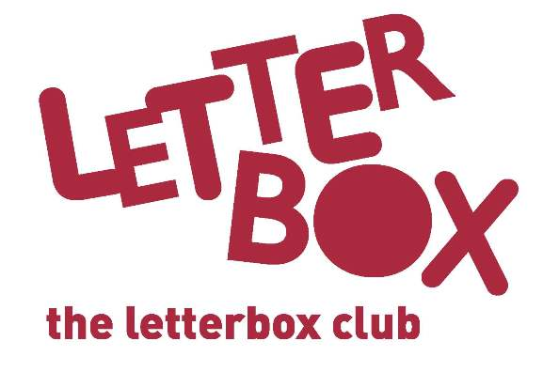

The Letterbox Club
[Insert local authority] is taking part in The Letterbox Club, a programme which aims to inspire a love of reading and engagement with numeracy in children who are looked-after aged 3-13. It’s run by a reading charity called BookTrust, in partnership with the University of Leicester.

Across the UK, children are enrolled for the Letterbox Club by local authorities and schools. Each child receives their own colourful parcel of books, number games, stationery and other supportive materials once every month for six months, all aimed at stimulating reading in the home. If the child moves during this time, parcels will be sent to their new address until the end of the programme. The family involved have been told about the programme.
If you would like to find out more about the parcels, so you can talk to participating children and families about the books and games, please contact the Letterbox Club team at Letterbox@booktrust.org.uk.

If you want to know about children who are taking part, please get in touch with [Insert local authority contact details].
How you could help...
Your role is crucial in providing support and guidance to foster carers. To build on the Letterbox Club programme, you could:
- Talk to children and carers about what’s in the parcels; what they liked and didn’t like about the stories or games…Did they do any activities together?
- Remind families that having special time together to read aloud, talk and look at the parcels is really important – just 10 minutes a day can make a huge difference!
- Reassure carers that the Letterbox Club isn’t homework; there’s absolutely nothing their child has to do. We hope that the Letterbox Club will encourage children to be more interested in reading, number, drawing and talking about their parcels!
- Carers may find that their child wants to look at one book over and over again, let them know that’s fine!
- Encourage carers to get involved too - they might want to do some drawing together with their child or talk about which stories their child enjoyed the most.
Thank you!

