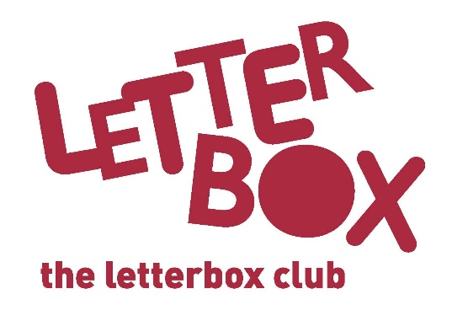
[LA Address]
[Street Address]
[Town/City]
[County]
[Postcode]

Dear [CHILD NAME],
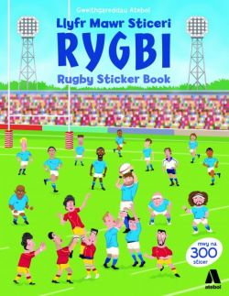
We hope you enjoyed last month’s parcel!

There’s more fun for you this month with Llyfr Mawr Sticeri Rygbi. We hope you enjoy making your own exciting training sessions and matches!

Then it’s time to have some fun and get creative, with The Treehouse Fun Book. There’s stuff to write, pictures to draw, puzzles to solve and so much more!

There’s also a book called The Accidental President. Imagine a 12-year-old suddenly finding himself President of the USA!

Plus, you’ve got some stickers and two games to play.

From,
[Local Authority contact]

P.S. Next month’s parcel will be the last one of the year so remember to keep an eye out for it in the post.

