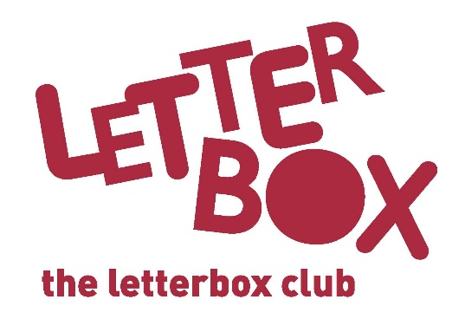
[LA Address]
[Street Address]
[Town/City]
[County]
[Postcode]

Dear [CHILD NAME],

What a parcel we have for you this month!
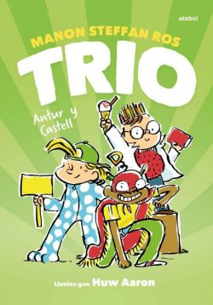
In Trio – Antur y Castell a group of friends try to stop a builder from knocking down Caernarfon Castle.

The author of The Phantom Lollipop Man!, Pamela Butchart, has even written you a letter to go with her book.

You also have The Phoenix Colossal Comics Collection.

And that’s not all – we’ve sent you some awesome name labels to stick in your Letterbox Club books.
We hope you enjoy your parcel!

From,
[Local Authority contact]

