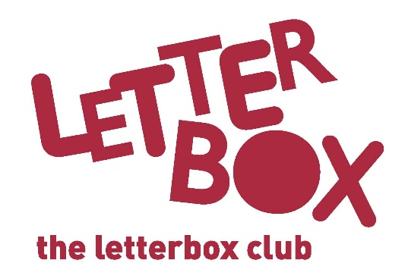
[LA Address]
[Street Address]
[Town/City]
[County]
[Postcode]

Dear [CHILD NAME],

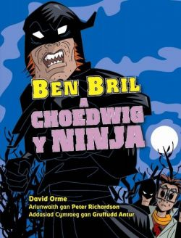
This month we have an action-packed story for you: Ben Bril a Choedwig y Ninja.

There’s weird but true facts in the National Geographic book you’ve got in this month’s parcel. There’s doodling to be done and stickers to stick in!

We hope you also enjoy the slippery story of Class Six and the Eel of Fortune.

Plus, you’ve also been sent a calculator to help you play the games in this month’s parcel.

It’s great having you in the Letterbox Club!

From,
[Local Authority contact]

