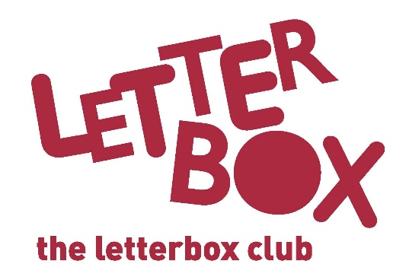
[LA Address]
[Street Address]
[Town/City]
[County]
[Postcode]

Dear [CHILD NAME],

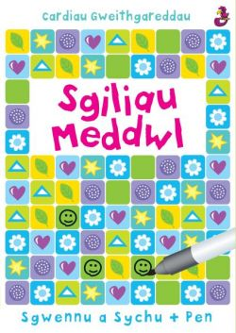
We hope you enjoyed your first parcel last month.

This month we’ve got Sgiliau Meddwl for you. There are puzzles galore waiting for you.

We you hope you enjoy the gripping story of the Museum Mystery Squad – they’re investigating the case of the moving mammoth!

In your parcel, you’ll also find The Awesome Book of Space. It has lots of facts about the universe and solar system.

That’s not all… we’ve sent you two bingo games and your very own Letterbox Club wristband.
Plus, you’ve got a postcard this month. We’d love to hear what you think of your parcel if you want to write to us.
We hope you have fun with the books and games in this month’s parcel.

From
[Local Authority contact]

