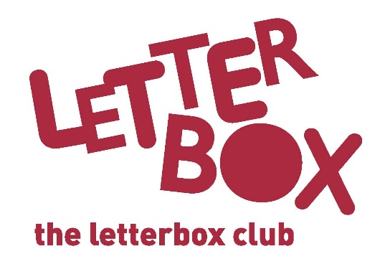
[LA Address
[Street Address]
[Town/City]
[County]
[Postcode]

Dear [CHILD NAME],

Welcome to the Letterbox Club!

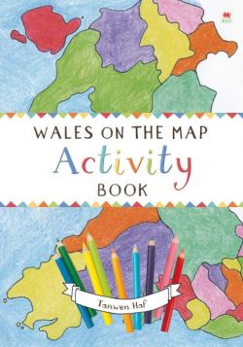
We’re so excited to have you in the club. Every month for the next six months, you will get a parcel full of fun books, games and stationery. Everything in the parcels is for you to own and keep.

This month we have Wales on the Map: Activity Book for you. It will take you on a voyage of discovery through Wales with lots of fun things to do on the way.

You can get creative this month, with Dare You to Doodle! You could use the pencil and eraser that also come with this parcel.

You’ve also got Dog Man – we hope you enjoy the story – and there’s a money game for you to play.

From,
[Local Authority contact]

