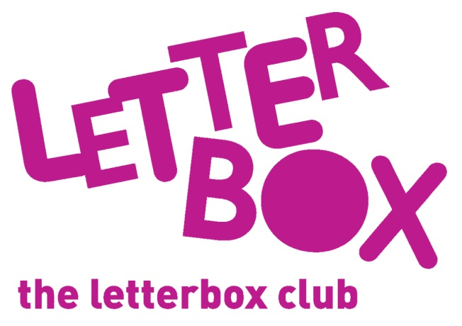
[LA Address]
[Street Address]
[Town/City]
[County]
[Postcode]

Dear [carer/parent and child],
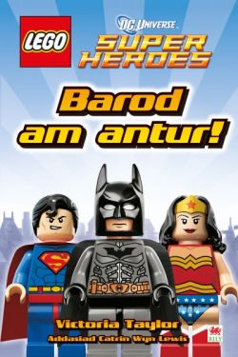
In this month’s parcel you’ll find a book called LEGO: Barod am Antur. Are you ready for a super hero adventure?

We’ve also given you a packet of six dinosaurs you can play hide and seek with.

And you’ll find a finger puppet in there too – we hope you’ll like it! How many do you have now?

From,
[Local Authority contact]

