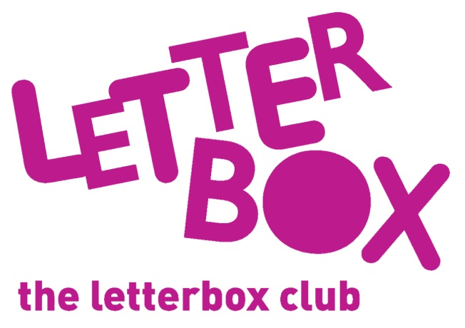
[LA Address]
[Street Address]
[Town/City]
[County]
[Postcode]

Dear [carer/parent and child],

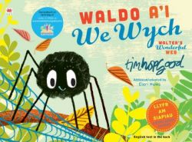
This month we’ve sent you a book called Waldo a’i We Wych. What kind of animal is Waldo?

You’re also getting a book called Follow the Trail – At the Zoo. Use your fingers to follow the glittery, bumpy, shiny trails and enjoy looking at the different zoo animals!

From,
[Local Authority contact]

P.S. How many finger puppets do you have now?

