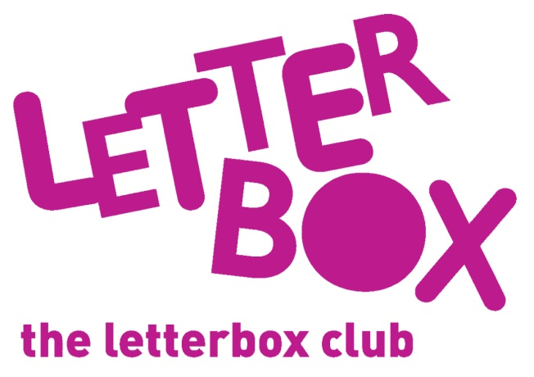
[LA Address]
[Street Address]
[Town/City]
[County]
[Postcode]

Dear [carer/parent and child],
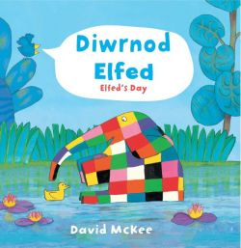
This month we’ve gven you Diwrnod Elfed in Welsh and English.

You’re also getting When the Moon Smiled, Fox’s Socks and Car, Car, Truck, Jeep in English. We hope you enjoy them.

We’ve sent you some beanbags so you can have fun while you count.

And we’ve put some stickers and a finger puppet in your parcel. We hope you have lots of fun!

From
[Local Authority contact]

