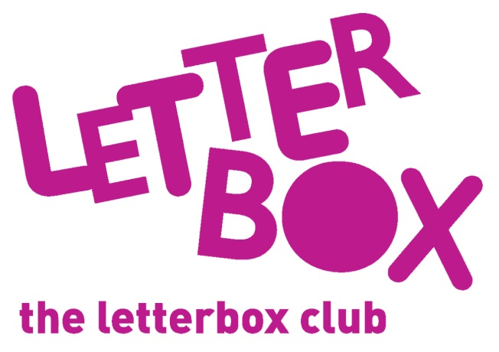
[LA Address]
[Street Address]
[Town/City]
[County]
[Postcode]

Dear [carer/parent and child],

Welcome to the Letterbox Club! We are so happy to have you in the club.

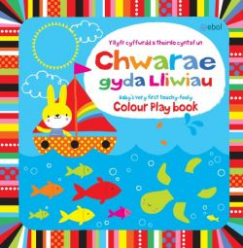
Every month over the next six months you’ll get a parcel full of books, games and stationary.

This month we’ve sent you Chwarae gyda Lliwiau and Off to the Park!

There’s a postcard and finger puppet in the parcel for you too!

From
[Local Authority contact]

