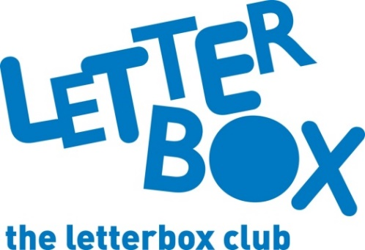
LA Address
[Street Address]
[Town/City]
[County]
[Postcode]

Dear [CHILD NAME],

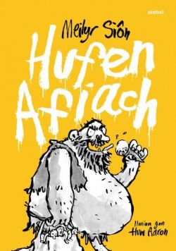
We hope you’ve enjoyed your Letterbox Club parcels!
Your last parcel of the year is full of goodies to enjoy!

Here’s Hufen Afiach for you. We hope you enjoy reading about the adventures of the friends from Cwm Cwstard.

You can try writing down your own story ideas in Write Your Best Story Ever! Notebook.

We’ve also sent you a story book from the classic children’s author, Roald Dahl, and you can have a laugh with The Funniest Space Joke Book Ever.

We hope you also like the money games.

Plus, don’t forget to check out short stories, activities and author interviews just for you on the Letterbox Club Members’ website. The website link is in this parcel on your own special membership card!
From,
[Local Authority contact]

