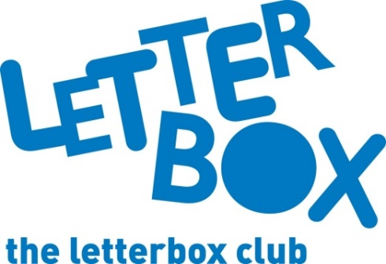
LA Address
[Street Address]
[Town/City]
[County]
[Postcode]

Dear [CHILD NAME],

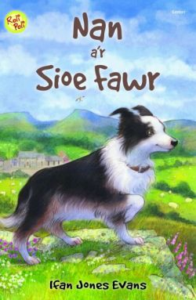
We hope you’re enjoying the parcels!

This month we’ve sent you something extra special – The Phoenix have put together a comic especially for Letterbox Club members like you.

We’ve also got Nan a’r Sioe Fawr for you. We hope you’ll enjoy reading about Nan the sheep dog getting ready for the Royal Welsh Show.

You’ll also find some specially made name labels that you can write on and stick in your books.

From
[Local Authority contact]

