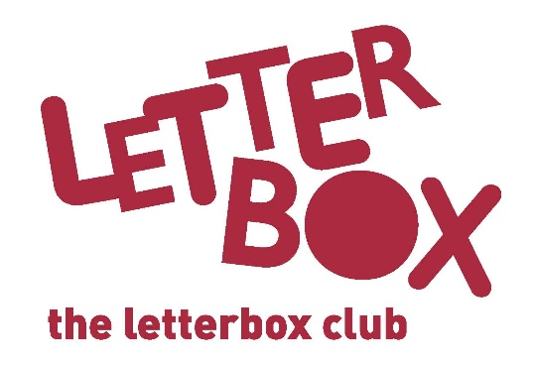
[LA Address
[Street Address]
[Town/City]
[County]
[Postcode]

Dear [CHILD NAME],

We hope you’ve enjoyed being part of the Letterbox Club!

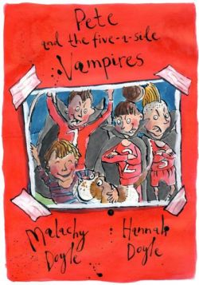
In this parcel we’ve got Pete and the Five-a-Side Vampires for you. Can Pete save the day or will The Horrors win?

We’ve sent you a special book from Guinness World Records, called Wild Things – it’s about some of the world’s most amazing predators.

You have a predators Top Trumps game and an activity where you can create your own predator – use your imagination!

We hope you also enjoy the money game.

Don’t forget to check out short stories, activities and author interviews just for you on the Letterbox Club Members’ website. The website link is in this parcel on your own special membership card.
Thanks for being a part of the Letterbox Club.

From,
[Local Authority contact]

