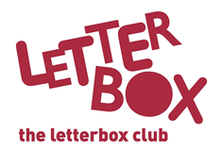
[LA Address]
[Street Address]
[Town/City]
[County]
[Postcode]

Dear [CHILD NAME],

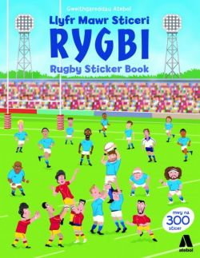
Here’s Llyfr Mawr Sticeri Rygbi / Rugby Sticker Book for you. We hope you enjoy making your own exciting training sessions and matches!

Then it’s time to have some fun and get creative, with The Treehouse Fun Book. There’s stuff to write, pictures to draw, puzzles to solve and so much more!

There’s also a book called The Accidental President. Imagine a 12-year-old suddenly finding himself President of the USA!

Plus, you’ve got some stickers and two games to play.

From,
[Local Authority contact]

P.S. Next month’s parcel will be the last one this year, so remember to keep an eye out for it!

