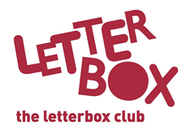

[LA/School Address
[Street Address]
[Town/City]
[County]
[Postcode]

Dear [CHILD NAME],
This month we’ve sent you Horrible Histories: Wales, which has a heap of extra-horrible facts all about Wales.

There’s more weird but true facts in the National Geographic book you’ve got in this month’s parcel. There’s doodling to be done and stickers to stick in!

We hope you also enjoy the slippery story of Class Six and the Eel of Fortune.

Plus, you’ve also been sent a calculator to help you play the games in this month’s parcel.

It’s great having you in the Letterbox Club!

From,
[Local Authority contact]

