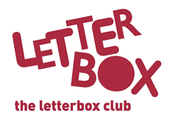
[LA Address]
[Street Address]
[Town/City]
[County]
[Postcode]

Dear [CHILD NAME],

Welcome to the Letterbox Club!
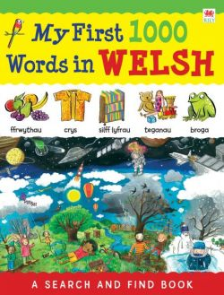
We’re so excited to have you in the club. Every month for the next six months, you will get a parcel full of fun books, games and stationery. Everything in the parcels is for you to own and keep.
Here’s My First 1000 Words in Welsh for you. You can get creative this month, with Dare You to Doodle! You could use the pencil and eraser that also come with this parcel.

You’ve also got Dog Man – we hope you enjoy the story.

Plus, there is a money game for you to play.

We hope you enjoy your parcel!

From,
[Local Authority contact]

