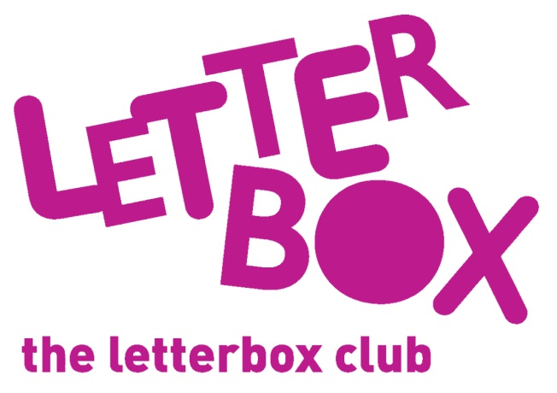
[LA Address]
[Street Address]
[Town/City]
[County]
[Postcode]

Dear [carer/parent and child],

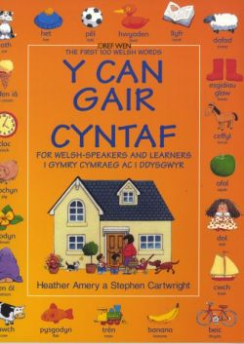
This month, we’re giving you a book called Y 100 Gair Cyntaf. There might be some new words to discover in it.

You also have Superkid, a book about an ordinary-looking boy with extra-ordinary powers!

Plus, you have a book of nursery rhymes that comes with a CD – we hope you enjoy listening to it.

You’ll also find a game for you to play with your finger puppet.

We’re so glad that you have been a part of the Letterbox Club!

From,
[Local Authority contact]

