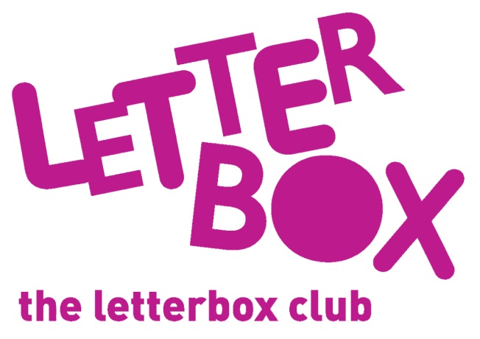
[LA Address]
[Street Address]
[Town/City]
[County]
[Postcode]

Dear [carer/parent and child],
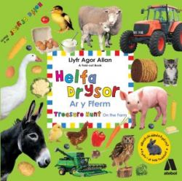
In this month’s parcel you’ll find Helfa Drysor: Ar y Fferm / Treasure Hunt on the Farm. Which animals do you think you’ll find?

You are also getting a pack of six mini dinosaurs to hide and find!

And, you’ll find a finger puppet too – we hope you’ll like it! How many do you have now?
From,
[Local Authority contact]

