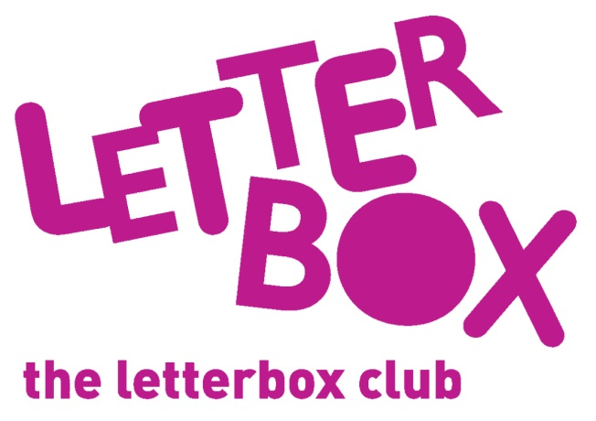
[LA Address
[Street Address]
[Town/City]
[County]
[Postcode]

Dear [carer/parent and child],
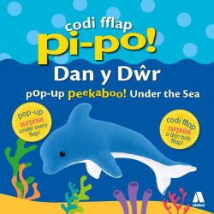
In your parcel this month we’ve sent you a book called Pi-po Dan y Dŵr – which animals do you think you’ll see?

There’s also Things That GO – it’s full of big stickers!

We’ve sent you 20 paper elephants for you to decorate too.

From,
[Local Authority contact]

P.S. Look out for your finger puppet this month!

