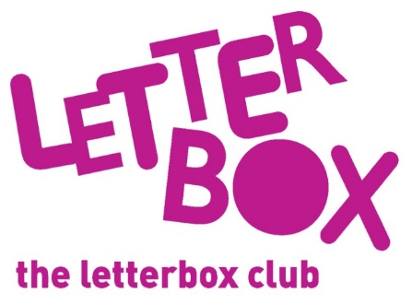
[LA Address]
[Street Address]
[Town/City]
[County]
[Postcode]

Dear [carer/parent and child],

Welcome to the Letterbox Club! We are so happy to have you in the club.

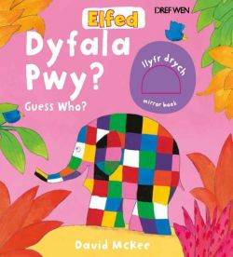
Every month over the next six months we’ll send you parcels full of books, games and stationery.

This month we’ve sent you Elfed: Dyfala Pwy? / Guess Who? and Off to the Park!

There’s a post card and finger puppet in the parcel for you too.

From
[Local Authority contact]

