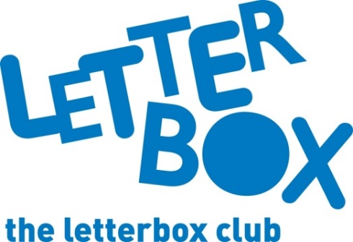
LA Address
[Street Address]
[Town/City]
[County]
[Postcode]

Dear [CHILD NAME],
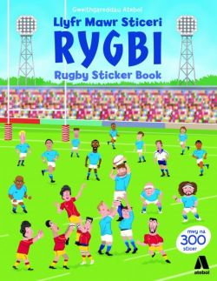
This month we’ve sent you Llyfr Mawr Sticeri Rygbi / Rugby Sticker Book. We hope you enjoy making your own exciting training sessions and matches!

We’ve also sent you 100 Facts: Animal Life and The Invincible Tony Spears.

Plus, we’ve put a post card in the parcel this time. We’d love to know what you think of the parcels if you’d like to write to us.

Next month’s parcel will be the last one for the year, but until then we hope you have lots of fun with this one.

From,
[Local Authority contact]

