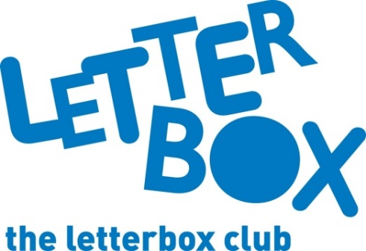
LA Address
[Street Address]
[Town/City]
[County]
[Postcode]

Dear [CHILD NAME],

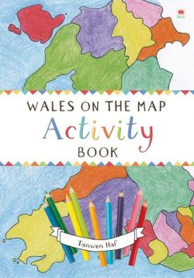
We hope you’re enjoying the parcels!

This month we’ve sent you something extra special – The Phoenix have put together a comic especially for Letterbox Club members like you.

There’s also a book called Wales on the Map: Activity Book that takes you on a voyage of discovery.

You’ll also find some specially made name labels that you can write on and stick in your books.

From
[Local Authority contact]

