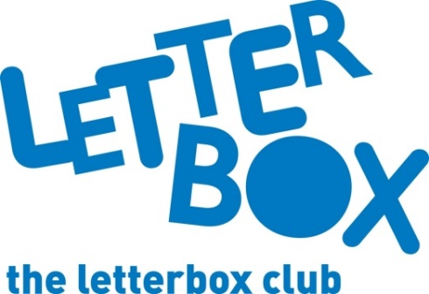
[LA Address
[Street Address]
[Town/City]
[County]
[Postcode]

Dear [CHILD NAME],
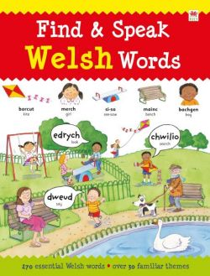
In your parcel this month we’ve given you a book called Find and Speak Welsh Words – are there any words that are new to you in there?

You also have a funny story called King Flashypants and the Boo-Hoo Witches.

You can also use your spare time to enjoy Holiday Boredom Buster. There’s plenty of doodling, colouring-in and puzzle-solving to be done!

Plus, this month you have your very own Letterbox Club wrist band.
It’s great to have you in the Letterbox Club!
From,
[Local Authority contact]

