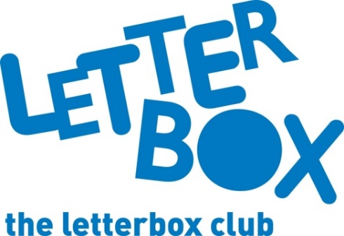
LA Address
[Street Address]
[Town/City]
[County]
[Postcode]

Dear [CHILD NAME],
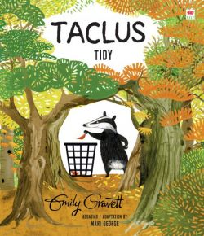
This month, we’ve sent you Taclus / Tidy, which is in Welsh and English, and Doodle Adventures: The Rise of Rusty the Robo-Cat! You can draw in the book to help Carl the duck on his mission!

Plus you can find out all there is to know about volcanoes and earthquakes – in a brilliant, colourful fact book. What are your favourite facts?

And if that wasn’t enough… you also have some fun bingo games!
From,
[Local Authority contact]

