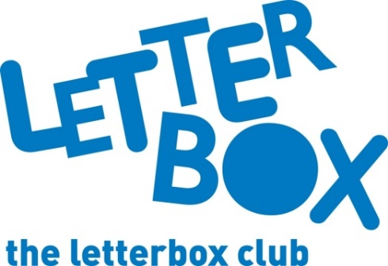
LA Address
[Street Address]
[Town/City]
[County]
[Postcode]

Dear [CHILD NAME],

Welcome to the Letterbox Club!

We’re delighted to have you in the club. Every month over the next six months you’ll get a parcel full of books, games and stationery. Everything in the parcels is for you to own and keep.
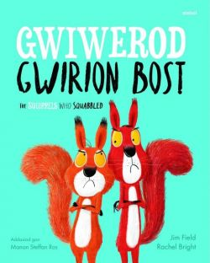
We’ve sent you Gwiwerod Gwirion Bost/The Squirrels Who Squabbled about two greedy squirrels who learn to share.

Fancy getting creative in your first parcel? We’ve sent you Drawing Lab: Superheroes.

In fact, it’s superhero central this month, because you also have a superhero card game and an activity!

We hope you also have fun playing the money game and creating your own superhero!

From
[Local Authority contact]

